UEN Legislative Update
February 26, 2021
In this UEN Weekly Report from the 2021 Legislative Session, find information about:
- Legislative Funnel Deadlines Approaching
- School Funding Signed by the Governor
- One-time Funding for Pandemic Instructional Costs Still Pending
- School Choice Bills Introduced in the House
  - HSB 240 Education Provisions and Open Enrollment
  - HSB 242 Charter Schools
  - HSB 243 Students First Education Savings Accounts (Vouchers)
- Bills receiving consideration this week, including ELL tiered weighting.
Legislative Funnel Deadlines
The first funnel deadline of March 5 is just one week away, by which time bills must be approved by a committee in their chamber of origin (House Files out of the House Education Committee, for example.) The second funnel, requiring bills out of committee in the other chamber, is April 2. There are some fine print exceptions, including appropriations bills, ways and mean (tax policy) bills, leadership bills and oversight committee bills. The funnels winnow down the mass volume of proposals to those that have a chance to move forward, allowing legislators, their staff, and lobby groups to focus their attention on priorities. The three new House School Choice bills, among others, will all have to clear the House Education Committee this week in order to move forward.
School Funding Signed by the Governor
SF 269 School Funding: the bill sets the SSA rate at 2.4%, for both regular program district cost and categorical supplements, increases the base to promote formula equity by $10 per student, includes property tax replacement by which the state assumes what would otherwise be a property tax increase due to the state cost per pupil increase, and appropriates additional funds for transportation equity to reimburse all school districts for transportation costs above the state average. The House passed the bill 56-36, the Senate passed it 31-18. The Governor signed it on Feb. 23, 2021.
Additional Details:
- The per pupil increase, combining SSA and formula equity, is $179, bringing the state cost per pupil up to $7,227
$36.5 M SSA
-15.0 M AEA cut
+ 5.8 M Formula Equity
+ 0.7 M Transportation
_______
$28.0 Million
- The total State aid from the General Fund (reflecting the total school aid funding level for school districts and AEAs generated through the school aid formula) is estimated to be $3.418 billion, an increase of $36.5 million (1.08%) compared to FY 2021. (If AEAs are cut the usual $15 million, the state aid impact is net $21.5 million)
- Any legislative action affecting FY 2022 school aid provisions will have an impact on school aid amounts and the assumptions could change too.
- The additional increase in the FY 2022 SCPP of $10 for a total of $5.8 million, which is included in the total State aid estimate.
- The FY 2022 General Fund appropriation of $27.5 million to the Transportation Equity Fund is $27.5 million.
The following table from the Fiscal Note provides additional information regarding the total funding for property tax replacement, now $86.6 million, the regular program increase of $1.6 million (very low due to lower enrollment of 5,924 students on Oct 1, 2020), a reduction of $7.4 million for preschool and 137 districts on the budget guarantee. The property tax relief payment is now $153 per pupil
UEN was registered opposed to the bill, which fell short of the 3.75% SSA request for adequate and sustainable funding. This level of funding was attainable with the average state investment of $95 million in the formula due to the year’s COVID-19 impacted enrollment decline. Negotiations for one-time funding for an instructional supplement are still under negotiations between the House and Senate, both at $27.2 million, but with different distribution formulas. See the Feb. 19 report for additional details.
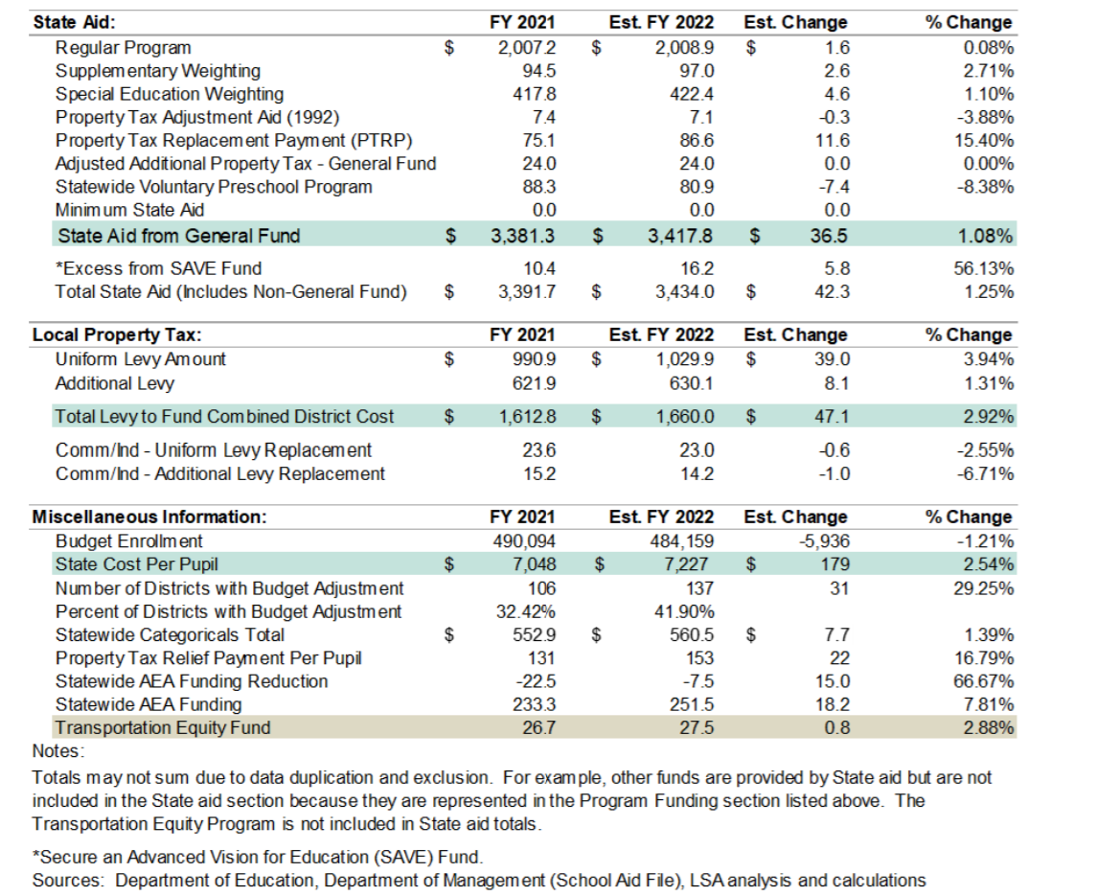
Note on One-time Funding Supplement: the House and Senate have not come to an agreement on a bill to provide one-time related to the costs of instruction during the pandemic. The Senate included $65 per pupil instructional supplement in SF 269 SSA which was amended out by the House. The Senate’s version includes FY 2022 one-time grants as misc. income, based on budget enrollment, requires the district to have always been in compliance with SF 2310, DE and Governor, which effectively excludes Des Moines. The total is estimated at $29.4 million. The House originally started with $30 million, but Rep. Hite stated during debate the Senate’s request that they lower the total to $27.2 million. The House version, HF 532, includes the following: grants of miscellaneous income in the current fiscal year, requires districts to report to DOM 14- days after enactment their count of qualifying days, limits the count to include the number of full-time instruction days (defined at 6 hours/day) from July 1, 2020 through Jan. 29, 2021, offered to all students districtwide, as one day, if between 3-6 hours offered to all students, as one-half a day, if in hybrid more than 6 hours offered to half of the students, counts are one-half a day. The bill includes provisions for districts that altered their calendar or return-to-learn plans due to the derecho storm in August of 2020 to receive credit for those days. The bill was approved by the House and is in the Senate Education Committee. UEN is registered opposed to both bills. We would have preferred the funding distributed equitably through the formula. However, UEN members will be grateful for the on-time funding and continue to advocate for a fair distribution method that doesn’t require a lot of bureaucratic work at the district to report. Stay tuned.
House School Choice Bills Introduced
The Governor’s SF 159, School Choice, as approved by the Senate on Jan. 28, 26:21, is still assigned to the House Education Committee with no action. However, various provisions of the bill were introduced this week as study bills. Each bill contains the language from the Governor’s School Choice bill as amended and approved in the Senate. Descriptions and status follows:
HSB 240 Education Practices and Open Enrollment: the bill has 6 divisions. Description of each section and UEN position is detailed below:
Division I Sections 1-3: Statewide single student information system: the bill requires the DE to provide a statewide student information system “designed for the purpose of establishing standardized electronic data collection and reporting protocols that facilitate compliance with state and federal reporting requirements, improve school-to-school and district-to-district information exchanges, and maintain the confidentiality of individual student and staff data.” It requires the school to pay for the system, at a per pupil level not to exceed costs of the system and including DE administrative costs. Concerns:
- schools use student information systems for significant work, grading which involves teachers/counselors/registrars and communicating with parents about student progress, tracking the 8th grade career plans, scheduling, tracking which students received interventions and the success of those interventions.
- Schools have invested in training everyone in the district to use the system they have. Districts of different sizes need different functionality.
- If the state picks one provider and negotiates details, the system will no doubt have more bells and whistles than some small districts need and be lacking the tools that drive our largest systems.
- Competition of different providers makes those providers continue to improve to earn or keep each school’s business. If there’s one state system, the vendor is accountable to the state for these purposes rather than accountable to local school leaders for what they need to accomplish.
- If this system is designed to make data collection and reporting for the state, it should save the DE money, not requiring school districts to pay for additional administrative costs.
- Current Code requires DE to have a comprehensive data management system which Sec. 3 strikes. This authority should be sufficient for the DE to improve data collection to coordinate reporting between stakeholders.
UEN is opposed to this provision.
Flexibility: Sections 4-8 of Division I create a flexible student and school support program established by state board to foster innovation, which includes the following details:
- State BOE approval exempts the district or nonpublic schools from one or more of the following:
  - specific curriculum requirements
  - physical activity requirements
  - provision of gifted/talented and at-risk programs
  - school start date
  - minimum days and hours
- Public and non-public schools may be granted participation for up to three years in the student and school support program to implement evidence-based practices in innovative ways to enhance student learning, well-being and post-secondary success
- This provision also provides ability of the school board to transfer ending balances from TSS and TLC remaining after meeting the requirements of the programs, to the Flex Account. Those funds can be used for any general fund purpose, for preschool expansion and for the addition of this new innovation program.
UEN supports this provision.
Division II: Education Tax Credits and Deductions: the bill increases the educator and tuition and textbook tax credits via the following:
- Educator expense deduction: Doubles the maximum amount a teacher/taxpayer may deduct from $250 to $500
- Increases the amount of allowed expenses from $1,000 to $2,000
- Increases the credit from 25% to 50% of eligible expenses
- Makes the credit refundable (excess of tax liability returned to the taxpayer)
- Makes homeschooling expenses eligible for the tuition and textbook tax credit.
The Fiscal Note to SF 159 estimates the impact of the tuition and textbook tax credit expansion to be $51.4 million. That alone is more money for private school education than was just approved for public schools in SF which educate 94% of Iowa’s children. If public schools receive about 43% of the state’s budget, we would expect a loss of $22 million for public schools down the road associated with this revenue reduction. UEN is opposed to this Division of the bill.
Division II: School District Enrollment Working Group: the bill creates a study group and specifies membership including a representative from UEN and a representative of a school district from UEN. Requires a study of on-time funding, budget guarantee and moneys that follow students for open enrollment purposes. A report is due to the GA not later than Dec. 1, 2021. UEN supports this provision and appreciates the inclusion of school leaders and interest groups included in this conversation.
Division III: Open Enrollment: Several provisions are more technical or clarifying in nature, such as
- allows open-enrolled students to participate immediately in sports if sports have been
- suspended in the original district but maintains ineligibility if the student is ineligible for academic reasons.
- makes the open enrollment deadline for pre-K students needing special education as Sept. 1
- adds to good cause the change in enrollment from one parent/guardian’s residence to another, and
- clarifies that the district of residence on count date is responsible for special education costs associated with an open enrollment.
Other open enrollment provisions:
- the addition of the ESSA designation as a school in need of comprehensive support and improvement and the Priority School designation from the Iowa School Report Card to the good cause list for open enrollment. (For examples, schools stay on that list for three years, even though they have improved sufficiently that they would no longer be on the list.)
- the addition of criteria of the failure of the resident district to reasonably respond to a student’s failure to meet basic academic standards, better addresses the intent of this provision. The bill requires the state Board of Education to establish criteria for this provision through the rule-making process.
- raises income eligibility for districts of residence to cover transportation costs for open enrolled students up to at least 200% of the federal poverty level. We are concerned that the state board could expand the eligibility further and would prefer the legislature define the limit.
- requires an open-enrolled athlete to fulfill an ineligibility for academic reasons. UEN also recommends that the provision requires that the receiving district require the student to fulfill any consequences of violating the student code of conduct policy.
Division V: this division specifies that school boards are responsible for improving student achievement, which we believe is already the expectation, so UEN has no concerns about this provision.
Division VI: Adds a work-based learning coordinator to shared operational functions. UEN is neutral on this provision.
UEN has registered opposed to this bill in its current form, but would change to neutral or even support with amendments to several provisions. The Subcommittee met on Thursday, Feb. 26, and received input from the education community and others regarding the bill. Further discussion and amendment is expected.
HSB 242 Charter Schools. UEN is opposed to this bill. If the second chartering option of charters founded by outside entities without school board approval is removed, UEN would register in support. Here are the details of the bill:
- Maintains provision allowing a charter school under auspices of a local school board
- Allows a “founding group” to apply to the state board for a charter for a new attendance center that operates independently of a public school district (does not require school board approval)
- Outlines the purpose of a charter school and what they should accomplish
- Defines terms and sets duty of the DE to monitor the effectiveness of charter schools and sets criteria for monitoring effectiveness
- Establishes a school board-state board model: allows a school board to create a “founding group” defined as a person, group of persons or education service provider that develops and submits an application for a charter school to the state board under this chapter. The school board can submit an application to operate a charter school within and as part of the district by establishing a new attendance center, create a new school within an existing attendance center, or convert an existing attendance center. The bill details the application requirements and requires a majority vote of teachers and parents/guardians with students in the district for a school board founding group to convert an existing attendance center.
- Establishes a Founding Group-state board model (new attendance center, not authorized by the school district). This provision includes the same requirements for application but no vote of parents or teachers is required
- Provides for a Charter school contract; requires DE to enter into a contract with approved charter school within 30 days, allows the initial contract for ten school budget years, allows delay of start up by one year, with the ability to request an extension if need more time.
- Specifies general operating powers and duties of the charter school. Exempts from all state statutes and rules and any local rule, regulation or policy applicable to a non-charter school except the following:
  - Federal, state and local health and safety requirements
  - Laws prohibiting discrimination
  - Subject to any court-ordered desegregation plan in effect for the school district in which the charter school is located
  - Operate as a nonsectarian, nonreligious school
  - Be free of tuition and application fees for Iowa resident students between ages 5 and 21
  - Comply with chapters 216 and 216A relating to civil and human rights
  - Provide special education services in accordance with 256B
  - Be subject to public school financial audits, audit procedures and audit requirements
  - Comply with transportation requirements for public schools
  - Comply with reporting and inclusion of student achievement in accreditation standards (256.7, sub 21) and educational standards (256.11) unless specifically waived by state BOE
  - Comply with minimum instructional time required unless specifically waived by state BOE
  - Cannot discriminate on admission but may limit to students within particular range of ages or grade levels or on any other basis if would be legal if initiated by a school district
  - Employ or contract with teachers with valid license
  - Must notify district of residence by March 1 of a student’s enrollment in charter school
- Funding provisions: District of residence pay to the charter school the sum of the following based on the prior fiscal year, 1) State cost per pupil, 2) TLC state cost per pupil, 3) ELL weighting times state cost per pupil, 4) PSEO funding $250 per course and required to be paid to the post-secondary institution offering the course.
- Performance Framework: requires the state BOE to evaluate charter schools based on Student academic proficiency, Student academic growth, Achievement gaps in proficiency and growth between specified populations, Attendance, Enrollment attrition, Post-secondary readiness, Financial performance and sustainability, Compliance with applicable laws, governing board stewardship. Requires annual performance targets to be agreed upon by charter school and state BOE and exempt from some requirements but still required to meet federal, state and local standards. Also requires the charter school to be evaluated and graded by the DE pursuant to the attendance center performance ranking system.
- Oversight – corrective action – contract renewal – revocation: the bill requires the State BOE to monitor compliance, provides a framework for correcting deficiencies, requires an annual charter school performance report by June 30 each year, and establishes renewal criteria
- Charter school closure procedures; the bill requires a protocol for orderly closure, notice to parents, asset distribution (if any) in priority order: 1) Outstanding payroll obligation, 2) Creditors of the school; 3) Public school district in which charter school operated
- Reports: requires an annual report to DE for each charter school and requires the state BOE to present findings for all charter schools to the legislature
- Eliminates existing charter school law for new charters (No new charter school approved under 256F.3 after July 1, 2021) and allows the operation of existing charter schools to continue to operate under 256F
- Adds students enrolled in charter school to the calculation of a district’s actual enrollment.
- SBRC requests: allows a school district to request modified supplemental amount from the SBRC for the opening or closing of a charter school, including if a charter goes bankrupt or charter is revoked and students return to the public school, allows the school district to ask the SBRC for spending authority to provide education for those students.
- Requires charter school board to determine the appropriate placement of a student on the sex offender registry and requires notice of such consideration on the board’s tentative agenda. If the student is denied enrollment, the district of residence is responsible for determining the appropriate placement.
- Good cause open enrollment: adds permanent closure of a charter school authorized under the new chapter to good cause criteria for open enrollment requests after March 1
See ISFIS Analysis of NAPCS Report linked here, which includes additional analysis about the impact of charter schools across the country.
HSB 243 Students First Education Scholarships (Vouchers). UEN is opposed to this bill. A subcommittee of Reps. Wills, Stone and R. Smith is assigned. A subcommittee meeting is scheduled on March 3 at noon in Room 103 (Supreme Court Chamber).
  - Voucher program for nonpublic students beginning July 1, 2022. Pupils eligible to enroll include incoming kindergarten, and students who have attended the school for two semesters, if the school of residence is identified in need of comprehensive support and improvement under ESSA. Any student who received a voucher in a prior year is also eligible (creates a permanent voucher program if the school later moves to an improved ESSA designation.)
- Scholarships for qualified educational expenses; goes directly to parent or guardian as debit card or checking account, Parents must apply by Jan. 31 and DE notifies parents/guardians of award by March 1. Must reapply annually.
- Amount of scholarship is determined based on the sum of the following for the same school budget year. Since students in nonpublic school won’t be counted for purposes of enrollment in the school of residence, these funds and others will automatically decrease from the resident district’s funding in the future.
  - Students actual weighted enrollment multiplied by 87.5% of the state cost per pupil plus the statewide average foundation property tax per pupil
  - Teacher salary supplement per pupil in resident district
  - Professional development supplement per pupil in resident district
  - Early intervention supplement district cost per pupil
  - AEA teacher salary supplement district cost per pupil in resident district
  - Teacher leadership supplement district cost per pupil
  - Calculation for the amount of the scholarship is the difference between 87.5% of SCPP and average foundation property taxes, which LSA calculated as $4,145 PLUS the individual district’s per pupil supplements. For state fiscal impact, the LSA estimates the amount as $5,270 + weightings. The bill requires any unused balance at high school graduation be returned to the state. (ISFIS estimates loss of revenue to school districts in excess of $9,000 per student that would have otherwise enrolled in the school district.)
- DE controls fund in state treasury. Makes a standing unlimited appropriation in an amount necessary to pay for the cost of all scholarships approved for that fiscal year. The Governor estimates $3.0 million in her budget recommendation.
  - Creates an account for each student in the state treasury fund – immediately available for payment of qualified educational expenses with total funds deposited July 1.
- Qualified educational expenses include
  - Tuition and fees at nonpublic schools
  - Fees or payments for educational therapies including tutoring or cognitive skills training
  - Curriculum fees and materials
  - Tuition or fees for nonpublic online education programs
  - Tuition for vocational and life skills education
  - Education materials and services for students with disabilities, including paras and assistants
  - Standardized tests, AP exams and other college entrance exam fees
  - New computer for the student’s use no more frequently than every 4 years
- Qualified educational expenses do not include:
  - Transportation costs
  - Cost of food or refreshments
  - Cost of clothing
  - Cost of disposable materials (pens, paper, notebooks, art supplies, etc.)
- Defines fraudulent practice and requires repayment of funds including litigation costs if used fraudulently (and detected). Requires parents to pay back the scholarship if the student is expelled or withdraws from the private school. If family moves to another district, does not have to pay back the scholarship if the student enrolls in another private school. Requires any remaining balance in the account be returned to the state when either the student graduates or turns 21.
- Explicitly states that it should not be construed to authorize the state or any political subdivision of the state to exercise its authority over any nonpublic school or to require a nonpublic school to modify its academic standards to receive payment from parents/guardians under this fund.
- Subtracts the amount received for scholarship from parent’s income for Iowa personal income tax purposes, to the extent it would be included in income.

Bill Receiving Action this Week
Bills to the Governor:
HF 308 Senior Year Plus Proficiency: this bill was amended to conforms to SF 262 to allow schools to jointly adopt rules with post-secondary schools for alternative measures of documenting proficiency for students to participate in Senior Year Plus programs. The Senate passed the bill 48-0. The House passed it 93-0, sending it to the Governor. UEN is registered in support.

Bills Approved by the Senate:
SF 261 CSC Non-Profit: this bill allows the College Student Aid Commission to organize a 501C non-profit to receive funds to provide educational assistance. Establishes incorporators and board members, requirements for open meetings, limits on receiving appropriations from the state and does not allow the corporation to pledge the credit of the state. Requires the CSC to give administrative support. The Senate passed the bill 48-0, sending it to the House. UEN is registered as undecided.

SF 265 School Promotions; this bill allows a parent to request that a child not be promoted to the next grade if the parent feels the child did not make adequate progress in the 2020-21 school year. Requires the request to be made by August 15, 2021. The Senate passed the bill 43-5, sending it to the House. UEN is registered as undecided.

SF 289 School Board Powers: this bill raises the threshold for AEA leases needing state approval to $100,000. Makes changes to the school board president elections. Strikes requirements that school boards report dues paid to IASB to the DE but requires boards to submit other reports that do contain that information. Makes changes related to the sale of school buildings and property, including how funds are deposited. Strikes newspaper reporting requirements for loans for equipment purchases. Changes and strikes other reporting requirements on sales of property. Strikes energy audits. The Senate passed the bill 48-0, sending it to the House. UEN is registered in support.
House Committee Action
HF 371 Teach Iowa Scholar Loans: this bill allows the use of funds from various discontinued teacher loan programs for the Teach Iowa Scholar loan program. Allows repayments for forgivable loans to be used for program. Makes technical changes. Approved 22:0 in the House Education Committee and moves to the House Calendar. UEN is registered in support.
HF 675 Substitute Teachers: this bill allows a person to be a substitute teacher with an AA degree or the completion of 60 credit hours of college. The bill as amended would maintain requirements for background checks and mandatory report training. Approved by the Education Committee 14-5 and moves to the House Calendar. UEN is registered in support.
HF 642 Sharing Special Education Directors (Successor to HF 150). The bill adds a special education director position to qualify for shared operational function weighting from the 2021-22 school year to the 2024-25 school year. The weighting of 3.0 students is assigned to the position. The House Education Committee approved the bill, which is now assigned to House Appropriations Committee. UEN is undecided on the bill.
Senate Committee Action
SF 466 Occupational Therapists and Concussions (By Education; Successor to SF 328): this bill deems occupational therapists as licensed health care providers for dealing with concussions in HS sports. UEN is undecided. The bill is on the Senate Calendar.
SF 467 On-Line Learning and Virtual Snow Days (By Education; Successor to SSB 1192): this bill Prohibits schools from using continuous on-line/remote learning unless done according to a proclamation by the Governor or following Iowa Code requirements of alignment, approval by DE or offer and teach flexibility limitations. The bill also allows for the use of on-line for snow/inclement weather for up to five days. UEN is registered in support, but looking for an amendment to clarify intentions. The bill is on the Senate Calendar.
SF 478 School First Amendment Rights (By Education; Successor to SSB 1205) 1st Amendment rights training for public schools and universities. Requires the protection of 1st Amendment rights for students. Requires that faculty be disciplined for violations of 1st Amendment rights. Requires the ability of student government organizations to use student fees be suspended for violations. Includes restrictions on what can be taught in training courses about race or sexism. Requires the Regents to create an Appeals Committee to deal with free speech issues. Requires the written publication codes for schools to incorporate these provisions. HSB 342 Companion in the House Judiciary Committee. UEN is registered undecided on the bill.
SF 480 Copying Records Costs (State Government; Successor to SF 218) this bill requires that costs for copying official records be reasonable. Does not allow costs for legal counsel for the review or redaction of records to be included. HF 637 Companion. The bill was approved by the State Government Committee and on the Senate Calendar. UEN is registered opposed.
Subcommittee Action
HSB 240 Education Provisions and Open Enrollment: see the bill description and details above. This bill is expected to be discussed in the House Education Committee next week to survive the funnel deadline.
HF 105 Open Enrollment Busing: this bill allows buses from a receiving district to travel into the district of residence to pick up student who open enroll with the sending districts’ school board permission. UEN opposes this bill.
SF 402 Banning Social Media Censorship; this bill prohibits the state or a political subdivision of the state (including school districts) from entering into contracts with, or providing tax incentives or any other benefits to, certain companies that censor online content. Although primarily focused on Facebook and Twitter, the bill would include technology companies such as Google, which provide resources for school districts. The bill requires the Attorney General to collect reports of potential violations and file lawsuits against the companies, under the bill. If a court found a company violated the prohibitions in the bill, the company would lose all contracts, benefits and agreements with governmental entities in Iowa for a 20-year period. A company could petition the court for a stay after four years.
Sen. Chapman was quoted in the media as saying the bill would apply to existing long-term contracts and tax breaks that a handful of Iowa cities already have with big tech companies that have built data centers. While the company would not have to pay back benefits, it would not be able to receive further benefits through those existing contracts. The bill was approved by the subcommittee, with two of the three senators recommending it move forward to the full Senate Commerce Committee. UEN is registered opposed to the bill.
SF 430 ELL Weighting: this bill will be amended to match the House version, which divides students with limited English proficiency into two categories for purposes of generating ELL supplementary weighting; 1) intensive which generates a weighting of .26 and 2) intermediate which generates a weighting of .21 (currently .22 weighting for students served in ELL programs.) Both student counts are based on test scores related to ELL proficiency. The statewide impact is estimated in the Fiscal Note to be $80,000. This bill was supported by the Subcommittee and is expected to be considered in the Senate Education Committee next week. Companion HF 605 is on the House Calendar. UEN is registered in support.
Connecting with Legislators: Find biographical information about legislators gleaned from their election web sites on the ISFIS site here: http://www.iowaschoolfinance.com/legislative_bios Learn about your new representatives and senators or find out something you don’t know about incumbents.
Find out who your legislators are through the interactive map or address search posted on the Legislative Website here: https://www.legis.iowa.gov/legislators/find
To call and leave a message at the Statehouse during the legislative session, the House switchboard operator number is 515.281.3221 and the Senate switchboard operator number is 515.281.3371. You can ask if they are available or leave a message for them to call you back.
Advocacy Resources: UEN recently launched a new website. More tools and resources will be added, but go to www.uen-ia.org to find Advocacy Resources such as Issue Briefs, UEN Weekly Legislative Reports and video updates, UEN Calls to Action when immediate advocacy action is required, testimony presented to the State Board of Education, the DE or any legislative committee or public hearing, and links to fiscal information that may inform your work. The latest legislative actions from the statehouse will be posted at: www.uen-ia.org/blogs-list. Check out the UEN Advocacy Handbook linked here, and also available from the subscriber section of the UEN website
Thanks to our UEN Corporate Sponsors: Special thank you to your UEN Corporate Sponsors for their support of UEN programs and services. You can find information about how these organizations may help your district on the Corporate Sponsor page of the UEN website at https://www.uen-ia.org/uen-sponsors.
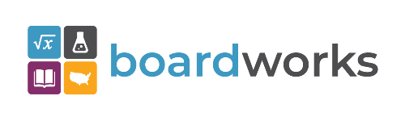 | www.boardworkseducation.com

Contact us with any questions, feedback or suggestions to better prepare your advocacy work:
Margaret Buckton
UEN Executive Director/Legislative Analyst
margaret@iowaschoolfinance.com
515.201.3755 Cell

