UEN 2023 Issue Brief
School Choice and the Priority of Public Schools

Current Reality: Iowa has a wide range of school choice options for parents and students, including:
- Within District Transfer: A neighborhood public school or a public school in another neighborhood within the school district (transfers regulated by the local school board).
- Open enrollment to public school in another district: 36,412 Iowa students exercised this option in the 2021-22 school year. This total includes: 1) Open enrollment to another district or open enrollment to an Iowa public virtual academy online program. Note: Legislation in 2022 removed the requirement to meet a March 1 deadline, so students can now open enroll to another public school district at any time.
- Charter Schools: HF 813 and HF 847, effective July 1, 2021, created new charter school options for school boards or independent founding groups.
- Strong nonpublic schools: with 36,636 students enrolled in 2021-22. Millions of state tax dollars support private schools and parents for school tuition organization scholarships, tuition and textbook tax credits, transportation/textbook funds to private schools, public school and AEA support for special education in private schools, and public/private partnerships for private preschool tuition in the statewide voluntary preschool program.
- Home School Options: competent private instruction or independent private instruction. HF 847 in 2021 applied the tuition and textbook tax credit to home school for the first time.
- Public funding for private education: In 2018, over $66 million of state dollars supported education of Iowa students in private and home schools, according to the Iowa Fiscal Policy Project Analysis Nov. 2018. The additional fiscal impact of HF 847 expanding tax credits to home school would raise that total to $91 million.
- Recent Iowa Expansion of Private School Support: In the 2021 session, School Flexibility and Choice, HF 847, accelerated the prior year’s increase of the annual cap for School Tuition Organization (STO) Tax Credits to $20.0 million from CY 2025 to CY 2022 and the credit was expanded from 65% to 75% of the contribution. These scholarships support private school tuition for students from families below 400% of the federal poverty level ($111,000 income for a family of 4). The bill also doubled the Tuition and Textbook Tax Credit to 25% of $2,000 spent and applied it to home school for the first time in CY 2021.
The Heritage Foundation’s Education Freedom Report Card shows Iowa ranked 9th in the nation in school choice: this ranking predated the expansion of charter schools, tax credits for home school and elimination of an open enrollment deadline.
Vouchers or Education Savings Accounts Costs Outweigh Benefits: Increasing Iowa’s public investment in private schools will not add benefits and will negatively impact public school students:
- Iowa has competition to pressure schools to perform (if the assumption is that competition provides positive pressure). According to the Economic Policy Institute Report, Feb. 28, 2017, “Research does not show that vouchers significantly improve student achievement.”
- That report concludes there are more effective ways to increase graduation and college attendance rates, that voucher/ESA programs have hidden costs including shrinking the pipeline into teaching, and that support for privatization detracts from more proven methods of improving student learning. Rural schools already find it hard to compete for employees and are concerned that increased demand for teachers in private schools, even if just in urban areas, will make it harder for rural schools to find teachers, already in short supply.
- Diverting funds to private education further stresses public school resources. From State Tax Subsidies for Private K-12 Education, Oct. 2016; “30 neovouchers across 20 states are draining over $1 billion in public revenues from state coffers every year. Every dollar of revenue diverted toward private schools is revenue that cannot be invested in the public education system.”
- Programs Start Small but Expand: school choice programs in other states tend to start small, often with eligibility available to low-income or students with disabilities. Though, over time, eligibility expands to include all students. For example, Ohio’s private school vouchers began as a pilot program, but has grown from $42 million a year in 2008 to $350 million in the 20-21 school year. With Iowa’s historic income tax cuts hitting the balance sheet with an anticipated $1.8 billion revenue reduction, the commitment to increase state support for private school will bump up against budget cuts in just a few short years.
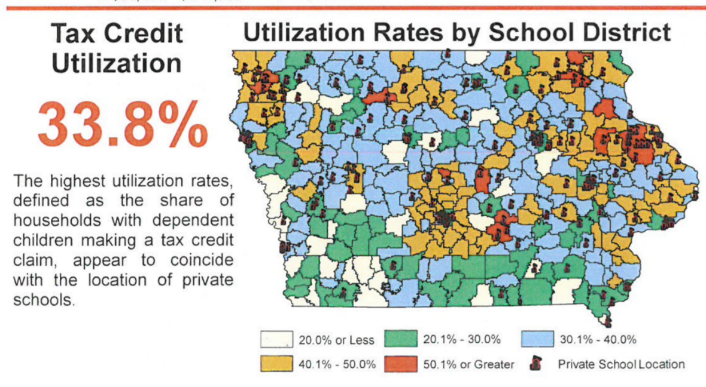
- Few Rural Private Schools: the survival of rural schools and variety of educational options for students depend on adequate state funding. There are few private schools available for rural parents to exercise choice, as this map from Iowa’s Department of Revenue presentation to the Tax Expenditure Committee measuring participation in tax credits, Jan. 2019, shows. As a result, the fiscal estimate for SF 2369 from the 2022 Session, anticipating a loss of $79 million to Iowa public schools, is expected to impact primarily urban school districts. Meanwhile, student poverty and minority concentration, particularly in urban areas, are exacerbated when families with means are encouraged to leave the public school for a private school program.
- Education Savings Accounts and Voucher programs reduce funds for public schools: Iowa school funding is enrollment based. If a student leaves the public school and enrolls in private school, the public district no longer counts the student in enrollment. Here are the fiscal impacts in FY 2023 dollars: Loss of $7,413 state cost per pupil (higher in 103 districts). Loss of state categorical funds estimated at $1,200 per pupil (professional development, teacher salary supplement, early intervention class size and teacher leadership and compensation). Loss of Dropout Prevention and Instructional support authority estimated at $874 per pupil but varies). Loss of State Penny for School Infrastructure of $1,133 per pupil. These combine for a minimum loss of $10,616 for each student, not including supplementary weighting for special education of English-language learner services. Federal funds and grant funds are also sometimes tied to student enrollment. The budget challenge for public schools comes in continuing to provide services when a few students leave from each grade, but not enough to reduce a teacher or course offering. Schools still have to be heated and buses still run the full routes.
- No Oversight: The Economic Policy Institute also finds insufficient budgetary oversight of voucher programs. There is no publicly elected school board or Department of Education regulation of allowable expenditures. The public does not have access to records or public meetings. Good stewardship of tax dollars requires transparency and clearly articulated expectations. The state of Florida’s ESA legislation requires an audit of private school expenditures if the private school receives at least $250,000 from parents’ ESAs. Iowa’s proposals of the past did not include any such oversight.
- Level the Playing field: Public schools are accountable to taxpayers, parents, communities (the public), and serve all students. Unlike public schools, private schools can refuse to enroll or later expel students not meeting expectations or refuse enrollment based on specific student needs, such as students with disabilities, non-English-speaking, minority, low-income or transgender students. If additional state dollars are used to fund ESAs, the private schools receiving those tax dollars should also be required to comply with testing, reporting, enrollment and service requirements.

Education Savings Accounts (ESAs) and School Choice
Iowa already has significant school choice. UEN opposes the creation or expansion of programs/plans that redirect or designate additional taxpayer funds for private school, homeschooling or other private services, regardless of whether those funds are provided indirectly through education savings accounts or directly through appropriations or tax credits. The priority of public schools demands adequate funding and support by the state. Investments in education savings accounts, voucher programs, school tuition organizations or homeschool remove resources from public schools in four ways:
  - Iowa’s funding formula is enrollment based. Fewer students mean fewer resources for staff, programs and courses for the vast majority of students remaining in the public school. For urban schools, students remaining in the school after some exercise a private option tend to be in neighborhoods with greater needs, such as higher poverty, more non-English speakers and higher minority concentration. Providing incentives for private schools has the effect of re-segregating our urban centers. The students who attend a private school with the ESA take with them not just the state funding estimated at $79 million by legislative staff, but also lower the public district’s resources by other significant sources of enrollment-based funding.
  - Carving Iowa’s education funding pie into more pieces necessarily means a smaller piece of pie for Iowa’s public school students. Urban school leaders, looking ahead to the implementation of the 2022 historic tax cuts, anticipate the inability of the state to adequately fund public schools, let alone, take on the commitment to fund a second educational delivery system.
  - School choice programs typically start small, but quickly expand eligibility criteria (increased income eligibility, support for home school, or even eventual public support of private tuition for any student at any private school that will take them). Although most of Iowa’s nonpublic schools today are religious, in the future, private online academies, the pressure for the state to support homeschooling and the profit motive to expand private schools without the corresponding costs of oversight and compliance will create additional budget pressures for our public schools and compete for teachers and other staff already in short supply.
  - Private for-profit schools may selectively enroll high-performing and low-cost students and are allowed to operate on an uneven playing field without fiduciary oversight or publicly elected representation.
UEN opposes all forms of education savings accounts/voucher programs/additional public funds appropriated for private or home school. Public funds should be used for public schools. Private funds should be used for private schools. Private school programs do not include accountability for expenditures, are not required to educate all children or provide special education services, and are hidden from the public oversight that should come with tax dollars. With unlimited open enrollment to any public school in Iowa, students and parents already have choices for which taxpayers have transparent access and accountability. Since private and home schools in Iowa already cost the state over $80 million annually, even small demonstration programs or pilot projects should be resisted.

