UEN 2023 Issue Brief
Preschool

- Background: Iowa’s Statewide Voluntary Preschool Program (SVPP), first implemented in 2007-08, has grown to serve 31,468 four-year-olds in 2019-20. PK enrollment was lower than kindergarten by 8,364, meaning as many as 27% of kindergarteners may not have been served in SVPP. The importance of reading proficiently by the end of third grade is critical, and quality preschool helps students reach that important benchmark. Preschool enrollment dropped from 31,468 to 27,392 (down 4,076 in October 2020 compared to October 2019) due to the pandemic. In October 2021, preschool enrollment rebounded to 29,411, still well short of the pre-pandemic level and still under-enrolled compared to the total relative population of four-year-olds expected to eventually attend kindergarten. Hold harmless budget provisions and programs to support early literacy are more important than ever in supporting Iowa’s youngest students to academic success.

Why does preschool matter? The Perry Preschool Project, 40 years later, documents $17 savings for every dollar invested (earlier findings of $8 saved for every dollar invested are also often cited). Once considered a strategy just to support working parents with childcare needs, the majority of states now view access to high-quality PK programs as a critical long-term economic investment in the future workforce. Education Commission of the States, http://www.ecs.org/docs/early-learning-primer.pdf Oct. 2014: Six rigorous, long-term evaluation studies have found that children who participated in high-quality preschool programs were:
- 25% less likely to drop out of school.
- 40% less likely to become a teen parent.
- 50% less likely to be placed in special education.
- 60% less likely to never attend college.
- 70% less likely to be arrested for a violent crime.

Sarah Daily, Initiatives from Preschool to Third Grade: A Policymaker’s Guide, shows reductions in costly outcomes that quality preschool prevents. (Denver, CO: Education Commission of the States, October 2014) http://www.ecs.org/docs/early-learning-primer.pdf. The National Conference of State Legislatures quotes studies on long-term return on investment. http://www.ncsl.org/research/human-services/new-research-early-education-as-economic-investme.aspx

Another study shows improved behavior and social skills: the Journal of Research in Childhood Education, The Long Term Benefits, 2017, http://dx.doi.org/10.1080/02568543.2016.1273285 demonstrates for low-income students in quality preschool compared to low-income students without the PK experience, the PK group had fewer behavior issues, referrals, better attendance, initially more special education in kindergarten (identified earlier) but less special education services by fourth grade than the control group.
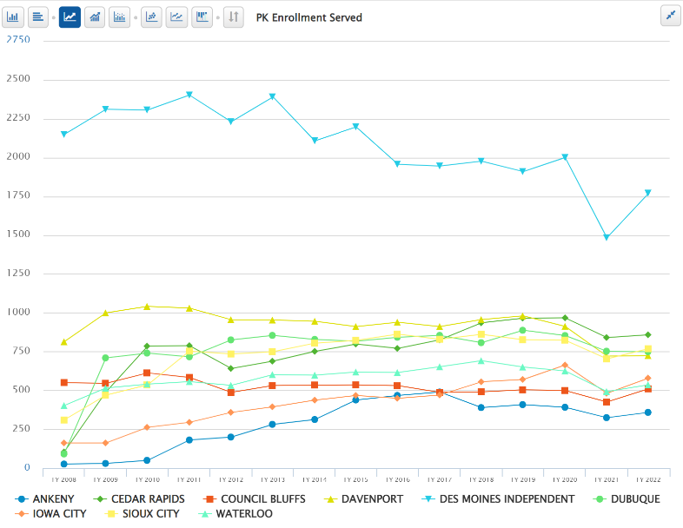
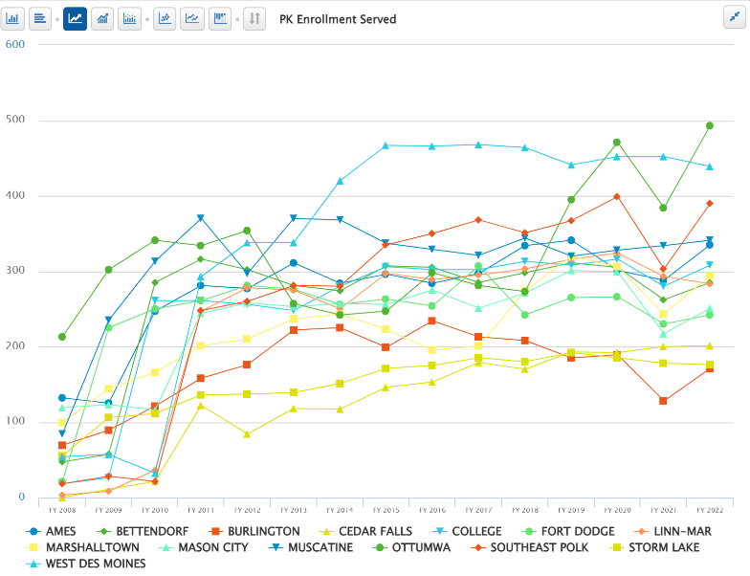
Barriers to Expansion. Preschool funding in the formula is paid entirely with state funds, based on the prior year’s enrollment of 4-year-olds in the program on October 1. Although 3-year-olds and 5-year-olds may be served, they are not counted for weighting/funding purposes. Unlike the regular program enrollment for K-12 budget purposes, there is no adjustment for enrollment growth known as on-time funding modified supplemental amount if more PK students are served than in the prior year. Districts are also prohibited from using general fund dollars to pay for PK expenses leaving parent pay or grant funding as the only remaining options. Additionally, 4-year-olds from low-income families may need other supports, such as full-day programs or wrap-around care to allow families full employment. For non-English-speaking families, preschool is critical, yet the 0.5 weighting is not enough to cover the costs of translators, staff and additional materials to support immigrant families to fully engage with their students, let alone the full-day programming that would jump-start their language development.

These charts show the rebound in PK enrollment in the 2021-22 school year following the pandemic and how far many districts still remain under pre-pandemic higher totals; on the top are UEN districts with two or more high schools (these 9 districts combined are still 11% below FY 2020 PK enrollment) and the lower chart shows the other 14 UEN districts (still collectively 3% below).

Workforce and Childcare: Full-day preschool with a 1.0 weighting for lower-income and non-English-speaking 4-year-olds is a win-win-win; 1) a win for students with improved academic success down the road, 2) a win for the business community when parents can fully engage in employment and freed up childcare slots can serve waiting lists so other parents can work, and 3) a win for taxpayers as students with quality preschool are 50% less likely to experience the costs of long-term special education typically borne by property taxpayers. Quality preschool is an excellent example of the old adage that an ounce of prevention is worth a pound of cure.

Quality Preschool: Iowa’s preschool program, initiated with strong support from the business community nearly a decade ago, should generate 1.0 weighting for full-day programming, including wrap-around services and child care for low-income or non-English speaking 4-year-old students. Such funding delivers a proven return on investment for both student achievement and taxpayers, while also freeing up childcare slots for younger children and allowing parents to fully participate in full-time employment. Increased weighting to provide services for Iowa’s English-language learners, low-income and at-risk students will close learning gaps while building a strong workforce.

