UEN 2023 Priority Issue Brief:
Mental Health Services
Background: Mental health challenges for students have increased in all school districts in Iowa, including urban schools. DE’s website shares how mental health conditions impact a large number of youth. A National Alliance on Mental Illness (NAMI) infographic includes the following statistics:
- 1 in 5 children ages 13-18 have or will have a serious mental illness.
- 50% of all lifetime cases of mental illness begin by age 14 and 75% by age 24.
- The average delay between the onset of symptoms and intervention is 8-10 years.
- Approximately 50% of students age 14 and older with a mental illness drop out of high school.
- 70% of youth in state and local juvenile justice systems have a mental illness.
In addition, in 2011, suicide became the second leading cause of death for youth ages 15-24 in the U.S. In 2014, suicide was the second leading cause of death for youth ages 10-14 in the U.S., though it dropped to the third leading cause in 2015. By 2019, suicide is again second. Leading Causes of Death and Injury Charts, CDC
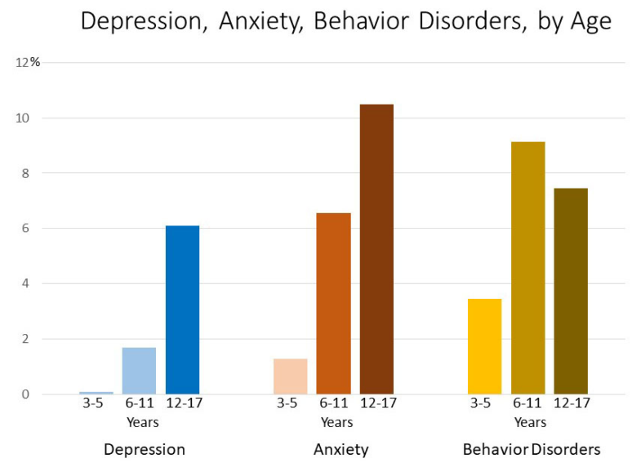
The CDC’s Statistics for Children Mental Health Website indicates conditions commonly overlap. For example, among children aged 3-17 years in 2016:
- Having another mental disorder was most common in children with depression: about 3 in 4 children with depression also had anxiety (73.8%) and almost 1 in 2 had behavior problems (47.2%).³
- For children with anxiety, more than 1 in 3 also had behavior problems (37.9%) and about 1 in 3 also had depression (32.3%).³
- For children with behavior problems, more than 1 in 3 also had anxiety (36.6%) and about 1 in 5 also had depression (20.3%).³

Unless a student is receiving special education services, mental health treatment at school is not funded. Even though services are more readily available in urban areas, there are long wait times. Parents have transportation barriers or job conflicts in getting children to needed care. During the pandemic, family job loss, quarantine requirements and illness added stress to families with mental illness. The need to continue this important work is more urgent than ever.
The good news: Research shows treatment works. Treatment for mental illness is effective. Like physical health conditions, it’s clear the earlier you get treatment for mental illness, the better.
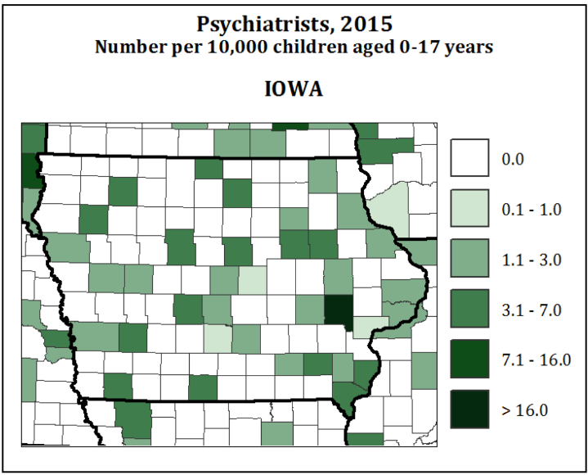
Recent Strides: in 2020, the Legislature created a pilot grant process for additional therapeutic classrooms. Funding for implementation was initiated in 2021 and increased in 2022. An appropriation of over $3 million to the Iowa AEAs in both 2021 and 2022 provided mental health awareness training for educators and mental health services. Additionally, the 2020 Iowa Legislature set schools as originating sites for virtual mental health counseling. This minimizes absenteeism, getting students needed help while at school when virtual counseling is appropriate. This CDC map shows the shortage of Iowa psychiatrists which can delay therapy. To address this shortage, the Legislature also created a mental health professional forgivable loan program beginning in 2022. UEN experts met in 2021 and agreed a collaborative approach is necessary to get students to services. However, no funding is provided for team-based case management to identify services not billable to private insurance, Medicaid or special education. This group also suggested an audio connection as a viable alternative when students lack the bandwidth to connect to telehealth services without video.

Appropriate Roles: Child mental health policies overlap areas of authority, intersecting human services, health care, county and state government and law enforcement. Education has a role in identifying students with needs (mental health first aid) and connecting students to services, but schools are not and should not be mental health providers. Schools are on the team, however, as student success depends on transitions returning from placements or scheduling and educational supports when treatment is ongoing. Schools should have the resources to educate students and staff about mental wellness, embedded throughout the curriculum where it is topical.

Mental Health Services: UEN leaders understand that mental health challenges must be addressed through a system that recognizes students and families with mental health needs are experiencing symptoms not only in school, but during the 17 hours a day and full days when they are not in school. Iowa needs an improved mental health system for children, including the structure and funding to eliminate the shortage of professionals. Schools should be partners to serve students and families, but educators are not trained providers of mental health care, nor do they have the capacity to meet the mental health needs of students. Students who have no outward indicators of mental illness suffer quietly, even leading to suicide. Well-known risk factors many Iowans already recognize include but aren’t limited to: students adjudicated or in residential placements, students with refugee trauma, and students experiencing adverse childhood experiences. Providing appropriate mental health services would position these students and their families for better academic, social and economic success. Iowa should engage in every opportunity to maximize school access to Medicaid claiming for health services for all students, not just students with individual education plans. Funds to provide case management and service coordination are required when Medicaid, special education or other categorical funds do not cover it. School districts require capacity and/or funding to provide:
1) transition support and services for students returning to school after a mental health placement,
2) ongoing teacher, administrator, and support staff training to improve awareness and understanding of child social-emotional, behavioral and mental health needs, 3) actionable classroom strategies to address student needs, and 4) integration of mental health promotion into instruction when appropriate.

