UEN 2023 Priority Issue Brief
Teacher, Administrator, Staff Shortage

Background: Iowa’s largest schools have traditionally been full of excellent teachers dedicated to student success. Competitive economic conditions, however, are making it difficult to attract and retain great teachers, indeed school employees in many different job roles, and it’s getting worse.
Many content areas are experiencing a shortage, especially at the secondary level. The Iowa DE compiles a list of areas with staff shortages annually. The list for 2022-23 includes the following, with new content areas this year underlined: deaf or hard of hearing impaired, visually impaired, special education (both II BD/LD and ID and I mild/moderate K-8 and 5-12), family consumer sciences 5-12, all world language, industrial technology, agriculture (5-12), all science (5-12), business (5-12), school counselor (K-8 and 5-12), mathematics (5-12), physical education, teacher librarian (K-8, 5-12 and K-12), early childhood education, earth science, physics (5-12), English language arts, music, art and all social studies. https://educateiowa.gov/pk-12/educator-quality/practitioner-preparation/teacher-shortage-areas. Almost all districts in Iowa are also struggling to find bus drivers, paraprofessionals, office staff, and food service workers.
When there are shortages, fewer qualified candidates apply to fill vacant and mandated positions, and sometimes no candidates at all. For example, as of Nov. 30, 2022, Des Moines Public Schools was still attempting to hire about 65 teachers and 30 special education associates (all but two associates in the area of special education), which means everyone else is doing double work. Private-sector competition is also compelling. Iowa’s employers are looking for a strong work ethic, communication skills, and the ability to get to work on time. The Future Ready Workforce list of High-Demand Jobs includes educators. Iowa was facing a teacher shortage before 2020; however, the effects of the global pandemic have amplified the shortage with staff retiring earlier than planned, retired teachers more reluctant to return as substitutes, increased needs for qualified staff to cover when teachers are sick, combined with increased educational and mental health needs of students.

Teacher Shortage Data:
- UEN member districts have experienced rapid growth in diversity and minority student populations. According to the DE’s Annual Condition of Education Report, 25.6% of students enrolled in public school were minority students. The UEN member districts enroll over 77% of all minority students in Iowa. Although statewide, 2.8% of teachers identify as a minority, for UEN districts, our teaching staff is 4.6% minority. The importance of additional recruiting resources and grow your own programs are necessary to continue to build a teaching force in which students see themselves, to building better relationships and improve student results. According to the Brookings Institute, The Importance of a Diverse Teaching Force, “Minority students often perform better on standardized tests, have improved attendance, and are suspended less frequently (which may suggest either different degrees of behavior or different treatment, or both) when they have at least one same-race teacher.” The article’s conclusion states, “As a consequence, the underrepresentation of minority teachers relative to the proportion of minority school-aged students could be having the effect of limiting minority students’ educational success. This has large potential effects for students and taxpayers alike: In addition to the strong economic and social benefits accruing to the students themselves when they graduate from high school, Levin and Rouse argue that the net benefit to taxpayers associated with each new high school graduate is well over $100,000.”
- The gap between Iowa Average Teacher Salary and the National Average, as reported in the 2021 Iowa Condition of Education Report, in 2020 was $5,949 (in 1988, the gap was $3,182). The estimated gap for 2021-22 places Iowa’s average teacher pay at $7,135 below the national average. Higher pay for teacher leaders, paid as much as $10,000 more for additional work through TLC plans, has helped to improve our average pay ranking since 2015. Iowa ranked #22 in 2018, however, Iowa slipped to #24 by 2021. From the 2021 Iowa Condition of Education Report: “Iowa’s average regular teacher salary increased slightly to $58,771 in 2020-2021 compared to $58,110 in 2019-2020. Iowa’s average salary is 24th in national rankings and 6th when compared to other Midwestern states in the 2019-2020 school year.” Urban school leaders are concerned that the gap continues to widen, with the Iowa teacher pay gap now 49% more behind the national average than in 2018-19.
- With significant teacher shortages across the nation, beginning teacher pay is critical in keeping Iowa graduates in Iowa and attracting graduates from other states. Iowa is in the second to lowest quintile and has slipped 8 places in recent years, now ranking 38th in starting teacher pay. Source: Understanding Teacher Compensation: A State-by-State Analysis
- Fewer teacher preparation candidates are graduating from colleges and universities of education, as reported in Teacher Retention and Recruitment: Shortages in Iowa/Nation, 50-state Comparison of Strategies, Education Commission of the States. In the Midwest states alone, between 2008-2017, there were 8,183 fewer graduates, for a loss of 17%. The following chart, compiled by Iowa School Finance Information Services, shows the nationwide data, which is even more drastic and predates COVID pandemic stressors on teacher supply.
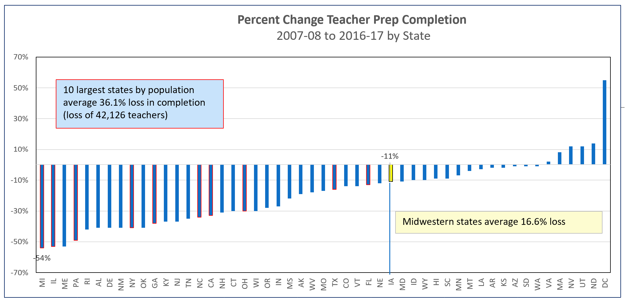
Current Reality: The qualified worker challenge impacts all schools in Iowa:
- The implementation of the teacher leadership and compensation system increased the demand for teachers to fill vacant positions to replace teacher leaders. TLC may also have slowed the pipeline of individuals willing to take on the work of school administration.
- Some urban schools have been able to help willing and capable teachers obtain certification in a shortage area of content, but the rules limit provisional licensure status to two years. Tuition and costs of coursework may be unaffordable on a teacher’s salary and nearly unattainable for new teachers, given the level of starting pay relative to ongoing college loan payments. Several UEN districts are excited to be participating in Gov. Reynolds Teacher and Paraeducator Registered Apprenticeship Program, through which programs are accessing federal pandemic funds to help participants become certificated or degreed over the next 2-3 years. Other urban grow-your-own programs are promising. State appropriation may be necessary to keep this program going.
- Some community members, dedicated to the urban community in which they live, may be willing to teach in areas of their expertise but can’t afford to quit working for two years to become certified in teaching. Some programs in CTE areas have provided avenues to on-the-job training, a good model which could be expanded. Other teacher-intern models would be helpful but must include student teaching and ongoing mentoring and support. Urban centers are rich with educated adults from all over the world who are bilingual, but there are many barriers to obtain licensure before employment in schools for these qualified adults.
- Beginning January 1, 2022, educators new to the state receive licensure reciprocity for their teaching, administrator or coaching license with a valid out-of-state license. This should help urban district recruit from historically black colleges and universities but competitive pay and benefits packages will be necessary to compete with districts from across the nation also vying for qualified minority teachers.

Teacher, Administrator, Staff Shortage
Adequate funding is essential for public schools to compete with the private sector in hiring new and retaining experienced employees. Recent steps to simplify licensure reciprocity with other states and eliminate IPERS barriers to rehiring retirees are welcome relief, but insufficient to eliminate staff shortages urban schools experience today. New policies should be implemented to help schools meet the challenge of attracting and retaining tomorrow’s educators and recruiting teachers that mirror our diverse students. UEN supports flexibility in certification requirements such as a K-12 special education credential, minimizing barriers for educators with international experience to teach in our schools, additional teacher intern programs that include adequate pedagogy/on-the-job classroom exposure, and continued support for grow-your-own programs, para and teacher apprenticeships, tuition support and loan forgiveness programs. Iowa’s Future Ready Workforce efforts should include an educator focus to replenish the talent pool and attract high school and college students to a career in education. UEN supported last year’s discussion in the Iowa Senate to use the Management Fund for loan forgiveness and recruitment programs. Of critical importance is the dedication of state and local leaders to generate enthusiasm for teaching by speaking about and treating educators with the respect the profession deserves and keeping great Iowa teachers in classrooms in Iowa.

