UEN 2023 Priority Issue Brief:
English Language Learner Supports
Services for ELL Students: The Urban Education Network (UEN) supports additional funding no lower than the national average (0.39) for ELL programming and state/regional capacity to assist districts with ELL students to improve instruction and evaluate programs for best practice. Students should be eligible for service for up to seven years based on their mastery of academic language at grade level. UEN supports flexibility for districts to best use funds to meet the needs of students and recognition of factors such as low income in meeting the learning needs of non-English speaking students.
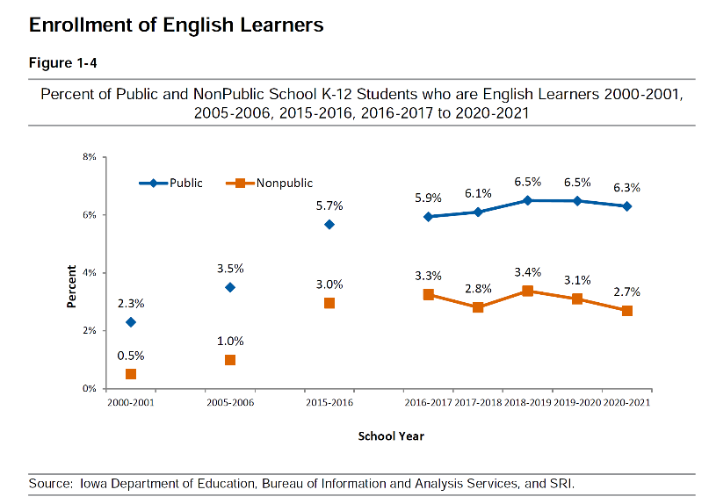
ELL Enrollment Growth
The number of students who are English language learners (ELL) continues to increase.
In the 2020-21 school year, 6.3% of students were reported as ELL, up from 2.3% in 2000-01, as reported in the 2021 DE’s Annual Condition of Education Report (Dec. 2021). Of the 46 Iowa school districts in FY 2021 with 6% or more of their enrollment eligible for ELL programing, 14 were urban districts and 32 are more rural in nature.

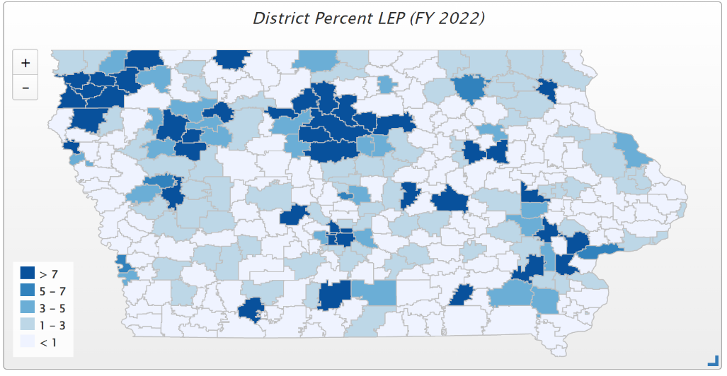
This map from the ISFIS Mapping Tool shows a geographically diverse impact, with the darker blue districts having ELL concentrations above 7% in FY 2022.

Funding History: The ELL Task Force Report, Nov. 2013, tells the history of the formula support for ELL services: “Prior to the 2013 legislative session, students served in an ELL program counted for an additional 0.22 weighting, including state contribution in the formula, for programming for up to four years. During the 2013 legislative session, state contribution was extended to a fifth year, first available to schools in the 2014-15 school year budget. Legislation enacted in 2021 HF 605 set two weightings to generate funding for students served in limited-English proficient programs based on need, which is a beginning to the tiered weighting based on student’s ELPA scores (Task Force recommendation): 1) An intermediate level with a weighting of .21 based and 2) An intensive level of .25 (both based on student ELPA test scores).
Educational Requirements: The Task Force Report also describes the responsibility of schools to provide services: In addition to federal law, Iowa has educational requirements for ELL students as defined in Iowa Code, Chapter 280.4, Uniform School Requirement: When a student is limited English proficient, both public and nonpublic schools shall provide special instruction, which shall include, but need not be limited to, either instruction in English as a second language or transitional bilingual instruction. Such instruction will continue until the student is fully English proficient or demonstrates a functional ability to speak, read, write, and understand the English language.

Funding Recommendations: The Task Force recommended and the UEN supports LEP weighted funding closer to the national average by increasing to an average of .39 through a phase-in formula over a three-year period. The .39 national average weighting was shown in the Nevada study, Study of a New Method of Funding for Public Schools in Nevada, American Institutes for Research, 2012. The Task Force also recommended extending eligibility for ELL state weighting from five years to seven years, reflecting the research-based timeline sufficient to move LEP students to proficiency: They state, “The extension of years is critical to provide enough time for all students to reach academic language proficiency through ELL educational programming to ensure they don’t fall into a subsequent designation of special education requiring an Individualized Education Program.”

Success: this chart shows that ELL students served early in elementary years tend to exit the program, as the numbers by grade level decrease dramatically through 6th grade.

How long does it take for ELLs to reach proficiency? The National Literacy Panel, as reported in A review conducted for the Center for Public Education by researchers at Edvantia, concluded that “considerable future research is needed to develop valid and reliable measures” of academic language proficiency (August & Shanahan, 2006). However, studies conducted to date indicate that it takes 4 to 7 years for ELLs to become proficient in academic English.” They cite several empirical studies that confirm the statement.

Student Opportunity Equity
Many Iowa students start school behind their peers, some by several grade levels. Iowa’s funding formula should include targeted funding based on the actual costs of closing achievement gaps for at-risk students living in poverty. Iowa’s preschool program, initiated with strong support from the business community nearly a decade ago, should generate 1.0 weighting for full-day programming, including wrap-around services and child care for low-income or non-English speaking four-year-old students. Such funding delivers a proven return on investment for both student achievement and taxpayers, while also freeing up childcare slots for younger children and allowing parents to fully participate in full-time employment. Increased weighting to provide services for Iowa’s English-language learners, low-income and at-risk students will close learning gaps while building a strong workforce.

