UEN 2022 Issue Brief
School Choice and the Priority of Public Schools

Current Reality: Iowa has a wide range of school choice options for parents and students, including:
- Within District Transfer: A neighborhood public school or a public school in another neighborhood within the school district (transfers regulated by the local school board).
- Open Enrollment to Public School in Another District: 35,227 students exercised open enrollment to another school district in 2020-21. Options include: 1) Open enrollment to another district via timely application, 2) Open enrollment for a good cause after the March 1 deadline, 3) Open enrollment to an Iowa public virtual academy and other online program.
- Charter Schools: HF 813 and HF 847, effective July 1, 2021, create new charter school options for school boards or independent founding groups. See DE’s guidance here: https://educateiowa.gov/sites/files/ed/documents/2021-07-02_CharterSchoolGuidance.pdf
- Accredited Nonpublic Schools: 33,840 students enrolled in 2020-21. Private schools and parents are supported by millions of state tax dollars for school tuition organization scholarships, tuition and textbook tax credits, transportation/textbook funds to private schools, public school and AEA support for special education in private schools, and public/private partnerships for private preschool tuition in the statewide voluntary preschool program.
- Home School Options: competent private instruction or independent private instruction. HF 847 in 2021 applied the tuition and textbook tax credit to home school for the first time.
- Public Funding for Private Education: In 2018, over $66 million in state tax dollars supported the education of Iowa students in private and home school settings, according to the Iowa Fiscal Policy Project Analysis Nov. 2018. The additional fiscal impact of HF 847, if the fiscal note assumptions prove correct, would raise that total to $91 million.
Vouchers or Education Savings Accounts Costs Outweigh Benefits: Increasing Iowa public investment in private schools will not add benefits and will negatively impact public school students:
- Iowa has competition to pressure schools to perform, if the assumption is that competition provides positive pressure. But according to the Economic Policy Institute Report, Feb. 28, 2017, “Research does not show that vouchers significantly improve student achievement.”
- That report concludes there are more effective ways to increase graduation and college attendance rates, that vouchers programs have hidden costs, including shrinking the pipeline into teaching, and that supports for privatization detract from more proven methods of improving student learning.
- Diverting funds to private education further stresses public school resources. From State Tax Subsidies for Private K-12 Education, Oct. 2016; “30 neovouchers across 20 states are draining over $1 billion in public revenues from state coffers every year. Every dollar of revenue diverted toward private schools is revenue that cannot be invested in the public education system.”

- Recent Iowa Expansion of Private School Support: In the 2021 session, School Flexibility and Choice, HF 847, accelerated the prior year’s increase of the annual cap for School Tuition Organization (STO) Tax Credits to $20.0 million from CY 2025 to CY 2022 and the credit was expanded from 65% to 75% of the contribution. The bill also doubled the Tuition and Textbook Tax Credit to 25% of $2,000 spent and applied it to home school for the first time in CY 2021.
- Fiscal Impact Specific to Iowa: Gov. Reynolds signed the Education Freedom Pledge on Nov. 3, 2021, which states, “I pledge to support policies that promote parental rights in education and educational freedom. This includes the right of parents to voice their opinions at school board meetings and to take their children’s taxpayer-funded education dollars to the education providers of their choosing – whether it be a public, private, charter, or home school.” The cost of $7,227 for each nonpublic student (33,840 in 2020-21 per DE statistics webpage) and each home school student (22,050 per HF 847 fiscal note) is $403.9 million based on current school choice behavior.
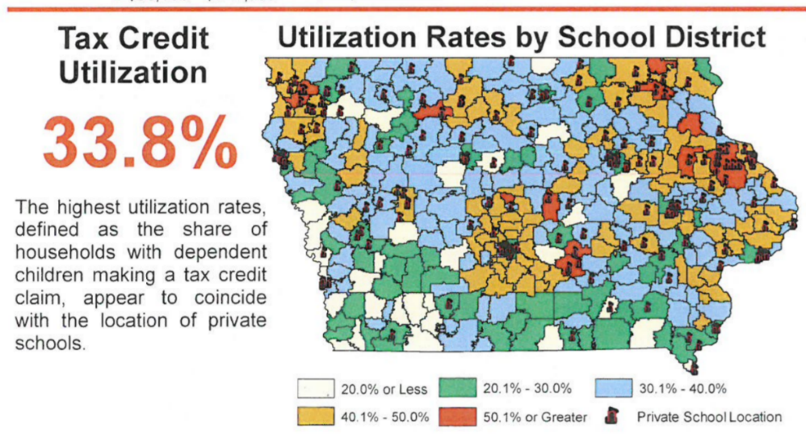
- Few Rural Private Schools: few private schools are available for rural parents to exercise choice as this map from Iowa’s Department of Revenue presentation to the Tax Expenditure Committee measuring participation in tax credits, Jan. 2019, shows. According to the National Rural Education Association, private vouchers reduce resources to rural schools and save money for parents in urban centers.
- Poverty/Minority Concentration in Urban Schools: student poverty and minority concentrations grow when families with means are encouraged to leave the public school for a private program.
- No Oversight: The Economic Policy Institute also finds insufficient budgetary oversight of voucher programs. There is no publicly elected school board or DE regulation of allowable expenditures. The public does not have access to records or public meetings. Good stewardship of tax dollars requires transparency and clearly articulated expectations.
- Level the Playing field: Public schools are accountable to taxpayers, parents, communities, i.e., the public, and serve all students. Public schools cannot refuse to enroll or expel students that are not meeting expectations or refuse enrollment based on specific student needs, such as students with disabilities, who are non-English-speaking, minority or low income. If additional state dollars are used to fund vouchers, the private schools receiving those tax dollars must also comply with testing, reporting, enrollment and service requirements.

The Urban Education Network of Iowa (UEN) calls on legislators and our governor to invest in Iowa’s public schools, which educate 94% of Iowa students, before further expanding private school and home school options unnecessary in Iowa’s already competitive education environment.

