UEN 2022 Issue Brief
Preschool

- Background: Iowa’s Statewide Voluntary Preschool Program (SVPP), first implemented in 2007-08, has grown to serve 31,468 4-year-olds in 2019-20. PK enrollment was lower than kindergarten by 8,364, meaning as many as 27% of kindergarteners may not have been served in SVPP. The importance of reading proficiently by the end of third grade is critical, and quality preschool helps students reach that important benchmark. Many parents chose not to enroll students in PK in the Fall of 2020 due to the pandemic, in Iowa and across the nation. PK dropped from 31,468 to 27,392 (Down 4,076 Oct. 2020 compared to Oct. 2019). Early indications of Oct. 2021 PK enrollment indicate that preschool is still under-enrolled. Hold harmless budget provisions and programs to support early literacy will be more important than ever next school year.

Why does preschool matter? The Perry Preschool Project, 40 years later, documents $17 savings for every dollar invested (earlier findings of $8 saved for every dollar invested are also often cited). Once considered a strategy just to support working parents with child care needs, the majority of states now view access to high-quality PK programs as a critical long-term economic investment in the future workforce. Education Commission of the States, http://www.ecs.org/docs/early-learning-primer.pdf Oct. 2014: Six rigorous long term evaluation studies have found that children who participated in high-quality preschool programs were:
- 25% less likely to drop out of school.
- 40% less likely to become a teen parent.
- 50% less likely to be placed in special education.
- 60% less likely to never attend college.
- 70% less likely to be arrested for a violent crime.

Sarah Daily, Initiatives from Preschool to Third Grade: A Policymaker’s Guide, shows reductions in costly outcomes that quality preschool prevents. (Denver, CO: Education Commission of the States, October 2014) http://www.ecs.org/docs/early-learning-primer.pdf. The National Conference of State Legislatures quotes studies on long-term return on investment. http://www.ncsl.org/research/human-services/new-research-early-education-as-economic-investme.aspx

Another study shows improved behavior and social skills: the Journal of Research in Childhood Education, The Long Term Benefits, 2017, http://dx.doi.org/10.1080/02568543.2016.1273285 demonstrates for low-income students in quality preschool compared to low-income students without the PK experience, the PK group had fewer behavior issues, referrals, better attendance, initially more special education in kindergarten (identified earlier) but less special education services by fourth grade than the control group.
Barriers to Expansion. Preschool funding in the formula is paid entirely with state funds, based on the prior year’s enrollment of four-year-olds in the program on Oct. 1. Although three-year-olds and 5-year-olds may be served, they are not counted for weighting/funding purposes. Unlike the regular program enrollment for K-12 budget purposes, there is no adjustment for enrollment changes; 1) no 101% budget guarantee if fewer students are served and 2) no on-time funding modified supplemental amount if more PK students are served than in the prior year. Due to COVID-19 pandemic, the Fall 2020 PK enrollment dropped significantly, which means that the 2021-22 PK budget will also drop significantly. Districts are prohibited from using general fund dollars to pay for PK expenses, so staff reductions are likely in the Fall of 2021. Additionally, four-year-olds from low-income families may need additional supports, such as full-day programs or wrap-around care to allow families full employment. For non-English-speaking families, preschool is critical, yet the 0.5 weighting is not enough to cover the costs of translators, staff and additional materials to support immigrant families to fully engage with their students. Des Moines Public Schools lost over 500 PK students. This chart shows the rest of UEN districts, with all but one showing the COVID PK enrollment drop.

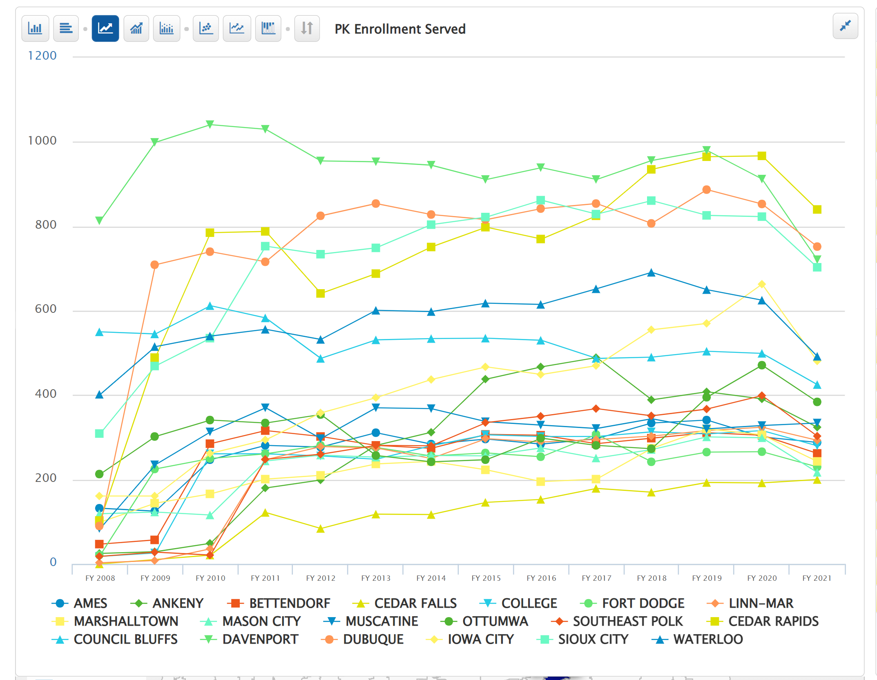

Quality Preschool: Early investment increases access to quality preschool programs which prevents higher costs later. Barriers to preschool access must be eliminated, and schools must have the funding and flexibility to provide preschool and wrap-around services for a full day, prioritizing high-need students first. UEN supports poverty and English-language learner weightings for preschool students and formula protections against the negative budget and program impacts of preschool enrollment swings.

