2022 Priority Issue Brief:
Opportunity Equity for High-Poverty Students
Background: Iowa’s funding formula does not sufficiently recognize poverty as a driver of at-risk student programing. In 2001, about 27% of students were eligible for Free/Reduced Price Lunch (FRPL). Dropout Prevention funding is based on total enrollment, not the percentage of students at-risk. Although flexibility for the use of DoP funds has been expanded, DoP capacity is still limited to 2.5% of the total regular program district cost or up to 5% of regular program district cost based on historical practice.
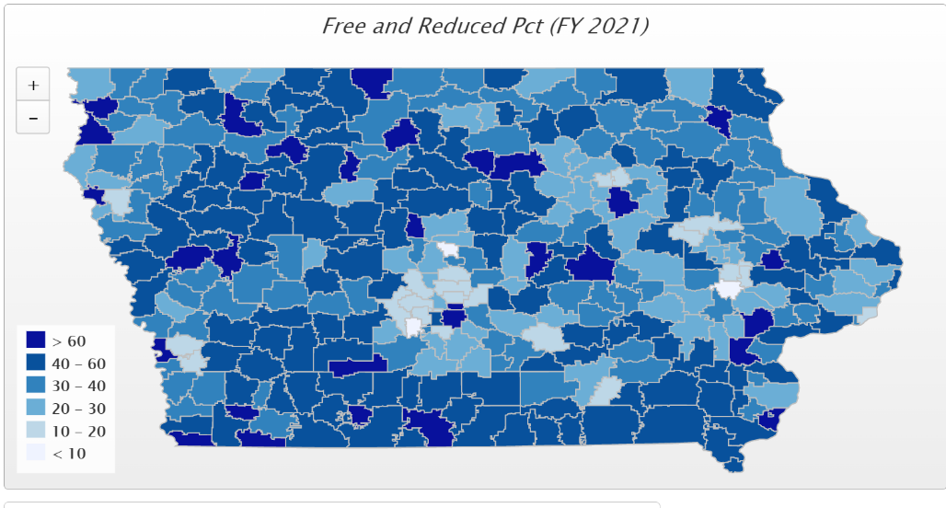
The December 2019 School Finance Interim Committee passed a unanimous and bipartisan recommendation to study the impact of poverty on educational outcomes. The committee saw this presentation by ISFIS reporting on other states, the national average of 29%, and the shortfall in Iowa compared to best practice. Here's a link from the Committee Legislative Website showing the presentation. The study was directed to review other states’ formulas that provide resources for students from low-income families which are showing successful student achievement outcomes for at-risk students. HF 2490 Poverty Weighting Study was approved with strong bipartisan support in the House Education Committee in the 2020 Session, but the issues have received no action since. This bill serves as a good starting point for continued conversation.
Current Reality: In FY 2021, 41.8% of students, or 202,007 children, were FRPL eligible, according to the Iowa Department of Education’s reporting.
- Poverty is now found throughout the state. It is no longer just an urban challenge. The map’s darkest color shows 78 districts with more than half of their student eligible for FRPL, and 31 districts have more than 60% of students eligible for FRPL. Those above 70% include Council Bluffs, Sioux City, South Page, Hamburg, Storm Lake, Clay Central-Everly, Denison, Marshalltown, Waterloo, Des Moines, LuVerne, Rock Valley, Postville and Stratford (6 of which are UEN member districts.)
- Iowa’s funding for at-risk (.48%) and dropout prevention (2.5-5%) combined are well short of the national average 29% weighting for low-income students. (AIR, Study of a new Method of Funding for Public Schools in Nevada, Sept. 2012). Since Iowa spends $1,280 less per student than the national average (Census data FY 2019 reported May 2021), the weighting per low income Iowa student, applied to a lower base, is inadequate to provide needed supports.

- Students from low-income families are more likely to begin school academically behind, exhibit nonproficient literacy skills, especially in early elementary, and fall further behind over summer breaks, unless schools have the resources, staff and programs to meet their needs.
- Low-income students are an important piece of Iowa’s workforce puzzle, will stay in Iowa, and either be the backbone of our communities’ potential or a drain on future resources.
- Districts must waive fees for FRPL-eligible families, meaning districts with concentrated poverty have fewer resources for textbooks and drivers’ education, further stressing the general fund.
- High-poverty School Investments boost achievement. Education Week, Student Outcomes: Does More Money Really Matter? Fresh research bolsters the case for K-12 cash—and a rough road without it, Daarel Burnette II, June 4, 2019 reports: "More money does, in fact, make a difference, they (researchers) say—provided that you spend enough, and in the right manner. They point to research in the past five years that provides examples of instances where politicians and taxpayers invested more money in teacher salaries, school construction, and schools with high populations of low-income students and saw students’ test scores jump.”
- The McCourt School of Public Policy, Georgetown, FutureEd, State Education Funding; The Poverty Equation, March 2020, states, “What’s more, when poverty is concentrated in a school—that is, when a significant portion of students in a school come from low-income households—the impact on performance is compounded. A body of research suggests that there is a ‘tipping point,’ somewhere between 50 to 60 percent of a school’s students living in poverty, where performance for all students there drastically declines.”
- UEN’s priority on student opportunity equity includes a long-term goal for Iowa’s formula to include a poverty factor weighting so districts with concentrated poverty have resources aligned to the needs for staffing, programs and supports for all students to reach success in postsecondary education or the Iowa workforce.
Student Opportunity Equity: close achievement gaps by increasing resources in the short term for English-language learners, minority students and early childhood/preschool with a long-term focus on low-income and at-risk students. Preschool budget protections from enrollment swings; including state funding for 2021-22 PK enrollment growth if federal funding is not forthcoming.

