UEN 2021 Legislative Priority:
Opportunity Equity for High-Poverty Students
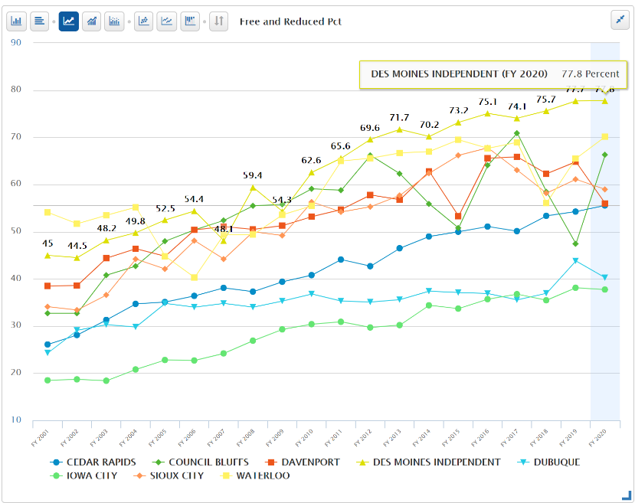
Background: In 2001, about 27% of students were eligible for Free/Reduced Price Lunch (FRPL), with the lowest district percentage of eligibility at 4.2%. That rate has increased significantly, now 42.0% statewide. All eight UEN Founding Districts have higher student poverty today than in FY 2001, ranging from a low of 38% in Iowa City Schools to a high of 78% in Des Moines Public Schools. Iowa’s funding formula, developed at a time when Iowa schools were not diverse, does not sufficiently identify low income as a driver of at-risk student programming. Dropout Prevention (DoP) funding is based on total enrollment count, not the percent of students at-risk, and is limited to between 2.5% and 5% of regular program district cost based on historical practice. At-risk funding is minimal and based half of enrollment and half on elementary FRPL eligibility.
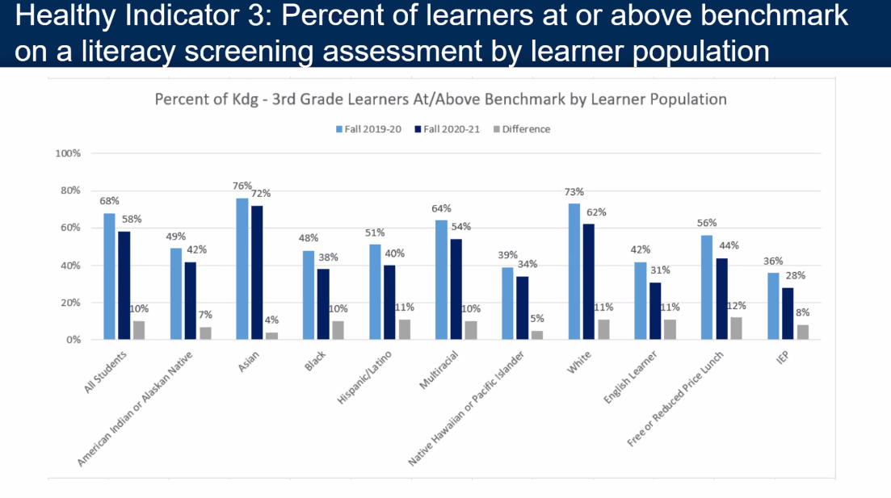
The December 2019 School Finance Interim Committee passed a unanimous and bipartisan recommendation to study the impact of poverty on educational outcomes. The study was directed to review other states’ formulas that provide resources for students from low-income families which are showing successful student achievement outcomes for at-risk students. HF 2490 Poverty Weighting Study was approved with strong bipartisan support in the House Education Committee in the 2020 Session but received no further action. This bill serves as a good starting point for continued conversation.
COVID-19 Impact: The Iowa State Board of Education received evidence of significant regression, or slide, in fall early literacy FAST testing in Iowa schools, due to school closure last March, including this chart by subgroup. It is no surprise that the low-income demographic group experienced the most significant learning loss, testing 12% below low-income early literacy performance in the Fall of 2019.

Additionally, quality preschool is proven to improve student learning and deliver a cost-benefit economic return down the road for taxpayers. Nationally, PK and Kindergarten enrollments dropped around 16-20% in Fall 2020, as parents just kept four-year-olds and five-year-olds at home for the year. Iowa’s funding formula does not protect districts from enrollment changes in preschool, meaning the fall of 2021 budgets will drop commensurate with the 2020 enrollment drop. Since school districts are prohibited from using general fund to pay for PK, there will be fewer PK slots available for students in the Fall of 2021 as a result. We do not know if parents of next year’s five-year-olds will want to enroll them in kindergarten or try to recover a year of PK experience, which is currently not funded for five-year-olds.
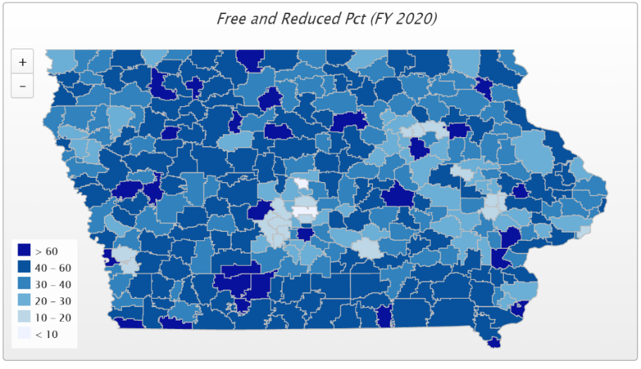
Current Reality: In FY 2020, 42.4% of students, or 205,947 children, were FRPL eligible, according to the Iowa Department of Education’s reporting.
- Although Iowa’s urban centers certainly exhibit concentrated poverty, it is now a statewide issue. The darkest color in the map shows districts with more than 60% of their students eligible. In FY 2020, 79 school districts in Iowa had more than half of their students FRPL eligible, among them, 8 of UEN’s 19 member districts.
- In districts with more than 7,500 students enrolled, 50.8% of students are free and reduced price lunch eligible.
- Iowa’s funding for at-risk and dropout prevention translates into less than 10% funding commitment for students in poverty, well short of the national average 29% beyond the base for low-income students. (AIR, Study of a new Method of Funding for Public Schools in Nevada, Sept. 2012)
- Students from low-income families are more likely to begin school academically behind, exhibit nonproficient literacy skills, especially in early elementary, and fall further behind over summer breaks, unless schools have the resources, staff and programs to meet their needs.
- Districts must waive student fees for FRPL-eligible families, meaning those districts with concentrated poverty have fewer resources for textbooks and drivers’ education, further stressing the general fund.
- High-poverty School Investments boost achievement. Education Week, Student Outcomes: Does More Money Really Matter? Fresh research bolsters the case for K-12 cash—and a rough road without it, Daarel Burnette II, June 4, 2019 reports: "More money does, in fact, make a difference, they (researchers) say—provided that you spend enough, and in the right manner. They point to research in the past five years that provides examples of instances where politicians and taxpayers invested more money in teacher salaries, school construction, and schools with high populations of low-income students and saw students’ test scores jump.”
- The McCourt School of Public Policy, Georgetown, FutureEd, State Education Funding; The Poverty Equation, March 2020, states, “What’s more, when poverty is concentrated in a school—that is, when a significant portion of students in a school come from low-income households—the impact on performance is compounded. A body of research suggests that there is a ‘tipping point,’ somewhere between 50 to 60 percent of a school’s students living in poverty, where performance for all students there drastically declines.”
- Low-income students are an important piece of Iowa’s workforce puzzle, will stay in Iowa, and will either be the backbone of our urban communities’ potential or a drain on future resources.

Student Opportunity Equity (Close the Gap): Equity requires a needs-driven formula that funds programs for low-income, non-English speaking, and at-risk students.

Iowa’s funding formula has not kept pace with the changing needs of Iowa students. The formula must recognize the disproportionate cost of providing equal educational opportunities to students from low-income families. School districts should be granted spending authority for Free/Reduced Price Lunch (FRPL) eligible students’ fees mandated to be waived by state and federal law. The COVID-19 experience has also shown us glaring differences among student home support. This includes both the ability to engage in learning based on lack of internet connectivity, as well as the inability of some working parents to stay home to support required continuous learning. Experts anticipate a COVID-19 ripple effect will increase achievement gaps. UEN supports full attention to and implementation of the December 2019 School Finance Interim Committee recommendation to study the impact of poverty on educational outcomes, including other states’ formulas that provide resources for students from low-income families, which are showing successful student achievement outcomes for at-risk students. HF 2490 Poverty Weighting Study was approved with strong bipartisan support in the House Education Committee in the 2020 Session and serves as a good starting point for continued conversation.

Early investment increases access to quality preschool programs which prevent higher costs later. Barriers to preschool access must be eliminated, and schools must have the funding and flexibility to provide preschool and wrap-around services for a full day, prioritizing high-need students first. UEN supports poverty and English-language learner weightings for preschool students and formula protections against the negative budget and program impacts of preschool enrollment swings.

In addition to a poverty weighting in the Formula, UEN calls for resolution of other Formula inequities, including the elimination of the $155 district cost per pupil difference within 9 years and correcting the perverse proration formula for the Instructional Support Program by providing funding over the long term and spending authority in the meantime.

The proration formula established for Iowa’s Instructional Support Program years ago assumed full state funding. With zero state share, that formula has a perverse impact on resources for districts with low property value and low-income families, which actually require more, not fewer resources for instructional support. The proration formula is outdated, given strong systems in place to promote property tax equity and relief over the last decade. All school districts should be able to access the full instructional support amount approved by their voters or their school boards going forward.

