UEN 2022 Priority Issue Brief
Teacher, Administrator, Staff Shortage

Background: Iowa’s largest schools have traditionally been full of excellent teachers dedicated to student success. Competitive economic conditions, however, are making it difficult to attract and retain great teachers, indeed school employees in many different job roles, and it’s getting worse.
Many content areas are experiencing a shortage, but especially at the secondary level. The Iowa DE compiles a list, which for 2021-22 included deaf or hard of hearing impaired, visually impaired, industrial technology, special education (both II BD/LD and ID and I mild/moderate K-8 and 5-12), family consumer sciences 5-12, all world language, agriculture (5-12), all science (5-12), business (5-12), school counselor (K-8 and 5-12), mathematics (5-12), teacher librarian (K-8, 5-12 and K-12), early childhood education, east science, physics (5-12) and all social studies. https://educateiowa.gov/pk-12/educator-quality/practitioner-preparation/teacher-shortage-areas
Urban school leaders are experiencing fewer applicants for positions in music, art, physical education and even elementary positions. Almost all districts in Iowa are struggling to find bus drivers, paraprofessionals, office staff, and food service workers.
When there are shortages, the market tends to draw teachers from rural areas lacking social amenities to higher-paying urban districts. Rural districts have experienced fewer qualified candidates, and sometimes no candidates at all, applying to fill vacant and mandated positions. Iowa’s urban districts are now also experiencing a labor shortage; teachers are being recruited to suburban districts, other states, or private-sector jobs which are also compelling. Iowa’s employers are looking for a strong work ethic, communication skills, and the ability to get to work on time. The Future Ready Workforce list of High-Demand Jobs includes educators. All of this information predates the COVID-19 global pandemic, which has encouraged earlier than planned retirement, reluctance for retired teachers to return as substitutes, needs for qualified staff to cover when teachers are out sick or in quarantine, and greater educational and mental health needs of students, all of which increase stress and responsibilities for classroom teachers.

Teacher Shortage and Comparative Pay Data:
- The gap between Iowa Average Teacher Salary and the National Average, as reported in the 2021 Iowa Condition of Education Report, continues to grow. Iowa’s average in 2020 was $5,949 less than the national average (in 1988, the gap was $3,182 and in 2019, the gap was $4,815). Higher pay for teacher leaders, paid as much as $10,000 more for additional work through TLC plans, has helped to improve our average total pay ranking since 2015. Iowa ranked 22 in 2018, however, slipped to 23 in 2019 and now 24 in 2020.
- With significant teacher shortages across the nation, beginning teacher pay is critical in keeping Iowa graduates in Iowa and attracting graduates from other states. Iowa is in the second to lowest quintile, ranking 30th in starting teacher pay. Source: A State-by-State Analysis of the Factors Influencing Teacher Supply, Demand, and Equity, https://learningpolicyinstitute.org/product/understanding-teacher-shortages-interactive
- Fewer teacher preparation candidates are graduating from colleges and universities of education, as reported in Teacher Retention and Recruitment: Shortages in Iowa/Nation, 50-state Comparison of Strategies, Education Commission of the States. In the Midwest states alone, between 2008-2017, there were 8,183 fewer graduates, for a loss of 17%. The following chart, compiled by Iowa School Finance Information Services, ISIFS, Inc., shows the nationwide data, which is even more drastic and predates COVID pandemic stressors on teacher supply.
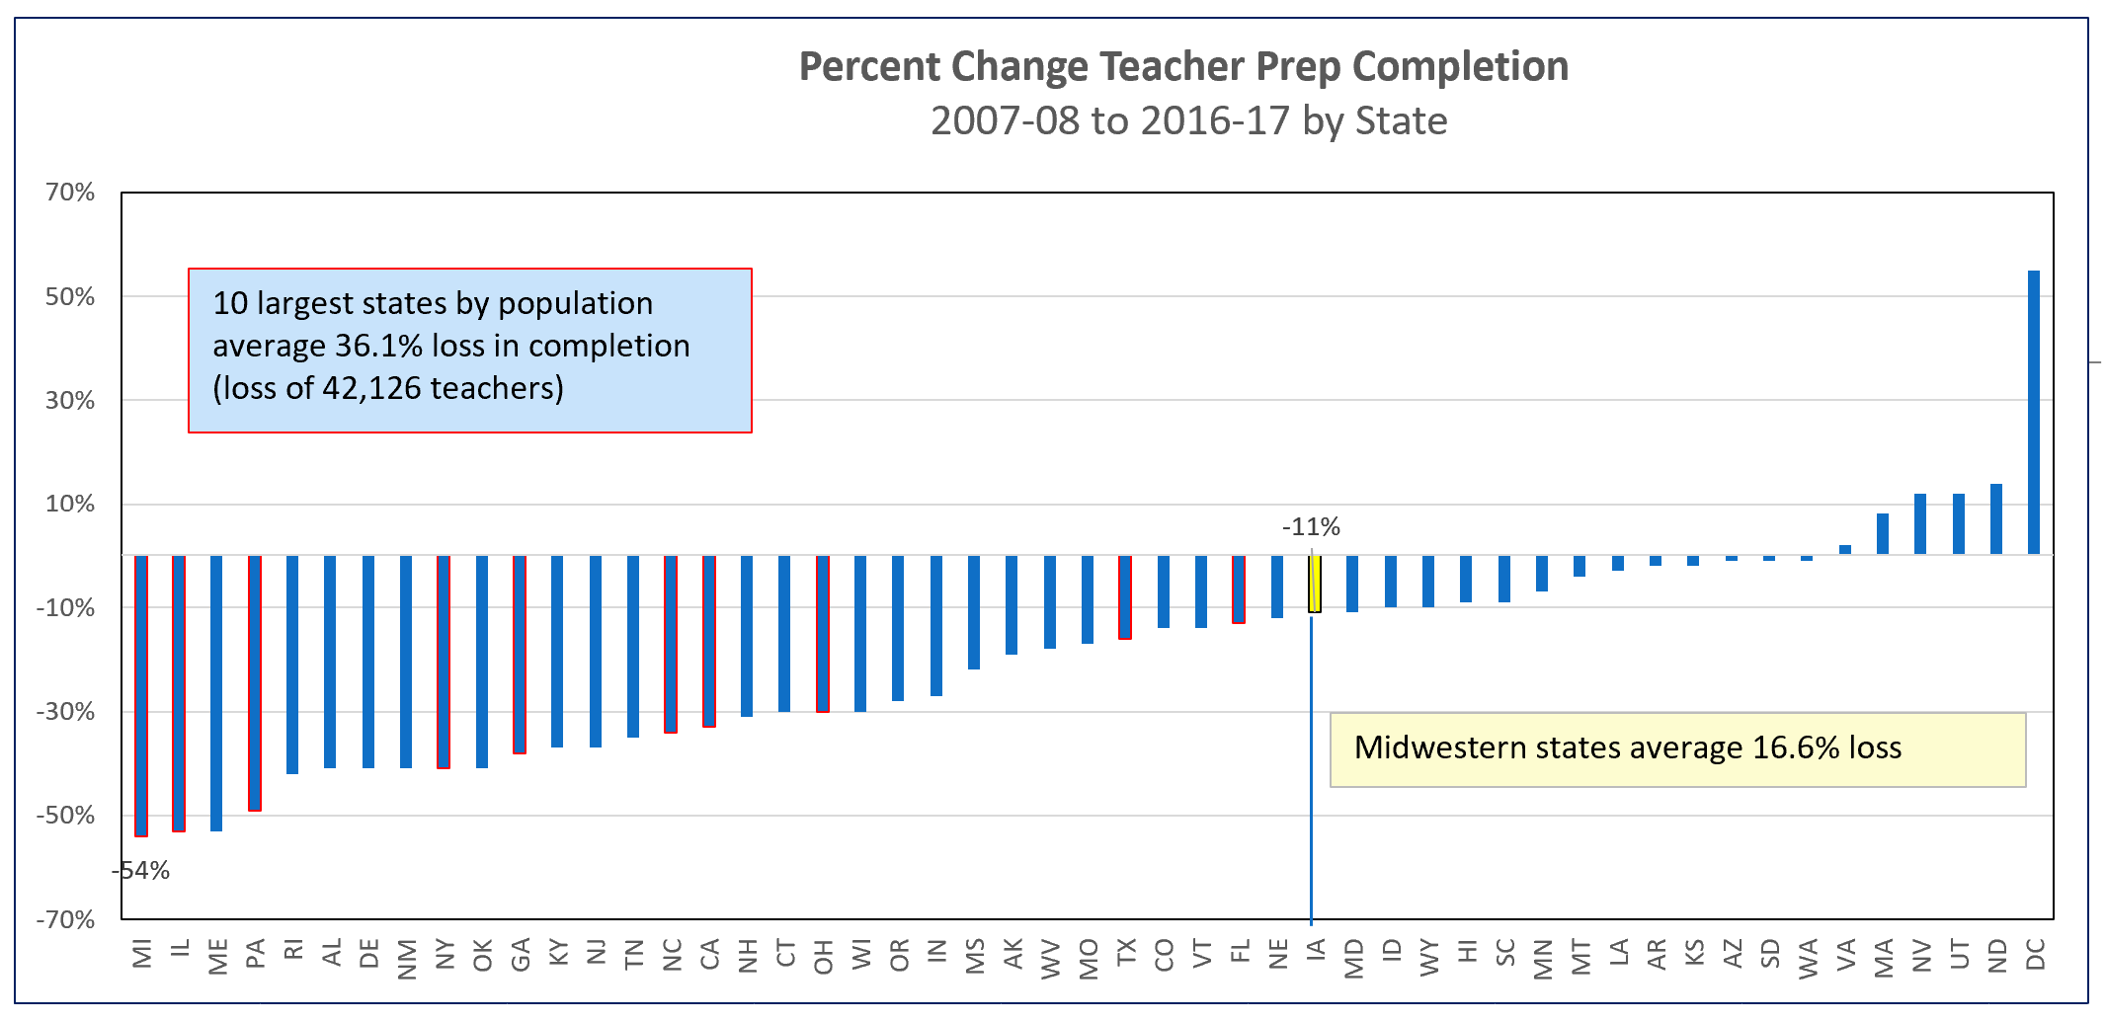
Current Reality: The qualified worker challenge is more difficult in urban Iowa:
- The implementation of the teacher leadership and compensation system increased demand for teachers to fill vacant positions to replace teacher leaders. TLC may also have slowed the pipeline of individuals willing to take on the work of school administration.
- Teachers in urban areas have larger class sizes and often a diverse student enrollment with specialized teaching approaches required. Despite very diverse student enrollment, however, urban districts struggle to hire teachers from varied race and cultural backgrounds. Urban school leaders are using ESSER federal pandemic funding to establish grow your own programs to recruit from within.
- Some community members, dedicated to the urban area, may be willing to teach in areas of their expertise but can’t afford to quit working for two years to become certified. Some programs in CTE areas have provided avenues to on-the-job training, a good model which could be expanded.
- Beginning January 1, 2021, educators new to the state receive licensure reciprocity for their teaching, administrator or coaching license with 1 year of experience. Although welcome relief, this does not allow new college graduates from other states to begin their teaching careers in Iowa without having to take courses not required in their university’s school of education program. The one year of experience requirement is especially challenging when recruiting from historically black colleges and universities.
Teacher, Administrator, Staff Shortage: promote staff diversity and talent, waiver of one-year experience for licensure reciprocity in recruiting diverse staff to better reflect diversity in student populations, flexibility in hiring, loan forgiveness programs and hiring retirees without negative IPERS implications. Iowa’s Future Ready Workforce should include an educator focus to replenish the talent pool and attract high school and college students to a career in education.

