UEN Legislative Update
April 4, 2024

This UEN Weekly Report from the 2024 Legislative Session includes:
- Budget Targets Set and Appropriations Bills Begin
- Governor’s Literacy Bill in the House
- Other Legislative Action
- Finishing the Session
- Advocacy Actions and Resources

Budget Targets Set and Appropriations Bills Begin
The Governor’s signing of HF 2612 SSA, Teacher Pay and AEA Reform last week opened the door for the rest of the budget process to begin. On Thursday of last week, the House and Senate released their budget targets. The Iowa Capital Dispatch article, Iowa House, Senate release competing budget targets for next fiscal year, shared many of the details:
- REC meeting earlier in March projected a 2.2% revenue decrease, but Iowa DOM director Kraig Paulsen said that the Iowa state government is in a strong financial position:
  - $1.83 billion general fund surplus
  - $2.74 billion in the state’s Taxpayer Relief Fund
  - $902 million in reserve funds
- The House budget proposes a state budget target of $8.955 billion for Fiscal Year 2025:
  - an increase of 4.71% or $402.8 million
  - $35 million higher than Governor’s recommendation (which was a 4.3% increase)
- Senate Republicans also released their budget target of $8.872 billion for FY 2025:
  - an increase of 3.7% or $320 million
  - $82 million lower than the House Republicans’ target and $47 million lower than Governor
- In a news release, Senate Republicans said their budget target includes:
  - an increase of $172 million for public K-12 schools through the AEA, teacher pay and school funding law (HF 2612).
  - an additional $51.25 million in new funding for Education Savings Accounts (applies 2.5% SSA increase. HF 68 last year phased in eligibility to 400% FPL in year two).

Once budget targets are set, the appropriations subcommittees get to work on appropriations bills, of which several have been through a couple of steps. The Education Appropriations subcommittee for SSB 3201 met Thursday and moved the bill forward to the full committee. This bill includes appropriations for community colleges, regents institutions, DE and several other education-related areas, with little impact on PK-12 public school funding, which is primarily funded in the Standings Appropriations bill yet to be introduced. UEN is registered as undecided. Items of interest in SSB 3201:
- Includes a new appropriation of $10 million to DE for new Division of Special Education established in HF 2612. This is half of the amount (an estimated $20 million) in the Governor’s recommendation for the Division, but HF 2612 specified no more than 13 staff at the DE in Des Moines and no more than 40 apportioned regionally in the AEAs, whereas the Governor’s plan included an estimated 139 FTEs. There is not yet a deappropriation, which could come in the Standings bill, out of school district/AEA special education flow-through.
- Includes $2.2 million to DE to develop and provide free required professional development for private and public school employees. There is not yet a deappropriation, which could come in the Standings bill, out of AEA professional development per pupil categorical funds.
- Please Note: There is no supplemental appropriation for $14 million in this bill, for school districts to increase pay for education support personnel. Such an appropriation could be amended on to this bill, be included in the Standings Appropriations bill, or not be appropriated at all. Stay tuned.

This chart from the Iowa Legislative News Service shows progress so far through Wednesday of this week.

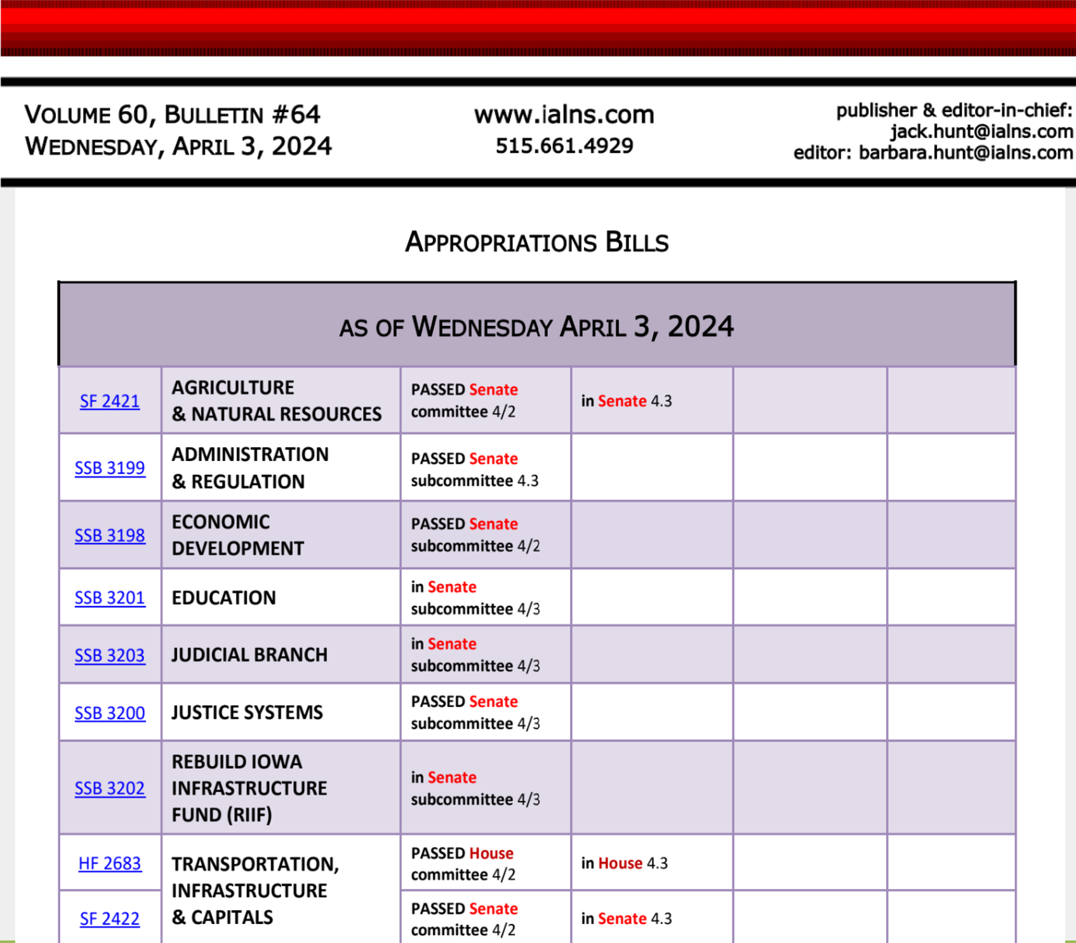

Governor’s Literacy Bill in the House
HF 2618 Governor’s Literacy Requirements: Requires the Foundations in Reading test be administered to students in Iowa Teacher Preparation programs. This is the Massachusetts test for assessing teacher skills in teaching and assessing early and elementary literacy. The bill requires the teacher preparation programs to report the test scores to the DE. The bill was amended to remove the requirement that a student have a passing score to graduate from the program or to be licensed to teach in Iowa. The bill also requires schools to give written notice to parents of K-6 students if the student is not proficient in reading, including a notice that the parent has the authority to request their child be retained. Prohibits promoting a student if the parents request the child to be retained. Requires schools to have individualized reading plans for K-6 students who do not read proficiently. The House approved the bill, 92-3, sending it to the Senate. UEN is registered as undecided.

Other Legislative Action
Bills to the Governor
HF 2393 Student Dental Exams: Exempts dental examinations for students from restrictions on physical exams, similar to exemptions for hearing and vision. House approved it 95-0 (2/28). The Senate agreed, 48-0, sending it to the Governor. UEN supports.
HF 2615 College Information to High School Students: Requires community colleges and schools that qualify for Iowa Tuition grants to publish information on students. Requires CCs to publish information on income and student debt of graduates. Requires schools qualifying for Tuition Grants to publish reports on the income and student debt of students with a bachelor’s degree. Requires High Schools give this information to grades 11-12 students who are interested in college. Makes the school college and career transition coordinator responsible for giving out copies of the report. Excludes a shared college and career transition coordinator from counting against the limits on supplementary weighting. An amendment in the Senate allows the information to be provided to students with an Internet link. Senate amended and approved the bill 48-0, sending it back to the House. The House concurred with the Senate amendment, 95:0, sending it to the Governor. UEN is undecided.
HF 2653 Perry Retention Bonuses: Allows Perry CSD to use no more than $700,000 from the district’s Management Fund balance, for teacher recruitment and retention. Approved by the Senate 49-0, sending it to the Governor. UEN supports.

SF 2331 Government Notices and Publication: Requires local governments to deliver minutes to newspapers for publication within 15 days. Requires the newspaper of notice to have been published for at least one year and that the newspaper post the official notices on their website at no cost to the public. Requires the paper to post to a statewide notice site. Requires a statewide newspaper organization to maintain such a site. Allows notice requirements to be satisfied by the local government’s internet publication (if it was timely), if the newspaper published untimely or in error. Allows a county to publish on the internet if no newspaper meeting the requirements for official publication exists in the county or if a newspaper refuses publication. Deems notice requirements to be met if the governmental body publishes notice on the internet even if the newspaper fails to publish the notice. Requires the newspaper to refund any money paid for notices not published in a timely manner. Gives the Iowa Public Information Board jurisdiction over disputes about notice publication between governments and newspapers. House amended and approved it, 95-2 (3/27) and the Senate agreed 47-0, sending it to the Governor. UEN supports.
HF 2465 AG Classes as Science or Math: Allows High School agriculture classes to include units that meet science and/or math curriculum requirements. Requires the state board of education to adopt rules. Limits the flexibility to no more than two units of Agriculture classes to meet offer and teach requirements. Deems the State BOE cannot waive certain requirements. The Senate concurred with the House 48-0, sending it to the Governor. UEN supports.

Bills Bouncing Between Chambers
HF 2278 Open Enrollment Transportation: allows a receiving district with fewer than 2,000 students to send a bus not more than 2 miles into the district of residence to pick up an open-enrolled student if the student lives closer to the school the student attends than the school of residence. Retaliation option: allows a receiving district of more than 2,000 students to send a bus into a contiguous district if that district is less than 2,000 students, and the district of residence has sent vehicles into the receiving district. The bill continues to allow receiving and sending school districts to reach an agreement on sending transportation into the district of residence. The Senate amended the bill to state that the sending district is not responsible for compensating the parent for transportation costs if the receiving district transports the student. Approved 49-0, sending it back to the House. UEN is undecided.

SJR 2004 - Single Rate Individual Income Tax Constitutional Amendment: Approved by the Senate 34-15, sending it to the House, where it is assigned to the House Ways and Means Committee. UEN is opposed.

HF 2487 Reporting Grooming Behavior: Adds grooming behavior to the kinds of discipline taken against teachers that must be reported to the BOEE. Defines such behavior by teachers. Adds Investigation provisions. Requires the BOEE to include the number of investigations of school employees who are not licensed or holders of certificates or authorizations that are referred to law enforcement in its annual reports. Includes protections for personal information. Requires the use of a unique identifier so that an investigation can be searched on the BOEE website but limits who can search. The House approved the bill as amended 99-0; the Senate amended the language to specify that grooming behavior would include a sexual rather than romantic relationship and specified that teacher use of alcohol or illegal drugs on school property or during school events is also a violation. The Senate amended and approved the bill, 49-0, sending it back to the House. UEN is undecided.
DE Director: Governor’s Appointee to the Department of Education, McKenzie Snow, was confirmed by the Senate, on a vote of 34-15, as the Director of the Department of Education.

Finishing the Session
See the March 15 UEN Weekly Report for School Start Date Status, Unfinished Business Calendar meaning and list of bills, Funnel Survivors and Dead Bills. April 16 is the last day of legislative per diem payments and they generally try to finish the Session by that time. The legislature has to debate some policy bills, if they intend to enact them. They need to move appropriations bills forward and come to consensus between the House and Senate budget targets and individual line item appropriations. They must approve whatever additional tax policy they intend to pass. Stay attentive to your email inbox this week in case some bad policies come back as amendments. Watch for moments to thank legislators for their work that supports your school district staff, students and communities.

Advocacy Actions
Share a Success Story in your School District: reach out to your Senator and Representative and share a success story of a great program helping students, a staff member going above and beyond, a student who has achieved an extraordinary achievement, a collaboration between your district and an AEA to solve a problem, or some community collaboration that is making a difference. If the story concerns quality preschool, you can easily transition to the next advocacy action.

Quality Preschool and Other UEN Priorities: Continue to talk about the value of Quality Preschool and Teacher and other Staff Shortages. SF 2383 Expanded Preschool is on the Senate Calendar but is unlikely to move forward due to the estimated impact of the bill on the state budget. The bill is phased in over two years, up to 1.0 weighting for students below 185% of the federal poverty level. Contact Senators to support it. Find Issue Briefs and other resources on the UEN Advocacy website to find talking points or other resources to share when you meet with policymakers.

Connecting with Legislators: To call and leave a message at the Statehouse during the legislative session, the House switchboard operator number is 515.281.3221 and the Senate switchboard operator number is 515.281.3371. You can ask if they are available or leave a message for them to call you back. You can also ask them what’s the best way to contact them during session. They may prefer email or text message or phone call based on their personal preferences.
Find biographical information about legislators gleaned from their election websites on the ISFIS site here: http://www.iowaschoolfinance.com/legislative_bios. Learn about your new representatives and senators or find out something you don’t know about incumbents.
Find out who your legislators are through the interactive map or address search posted on the Legislative Website here: https://www.legis.iowa.gov/legislators/find

UEN Advocacy Resources: Check out the UEN Website at www.uen-ia.org to find Issue Briefs, UEN Weekly Update Legislative Reports and Videos, UEN Calls to Action when immediate advocacy action is required, testimony presented to the State Board of Education, the DE or any legislative committee or public hearing, and links to fiscal information that may inform your work. The latest legislative actions from the Statehouse will be posted at: www.uen-ia.org/blogs-list. See the 2024 UEN Advocacy Handbook, which is also available from the subscriber section of the UEN website.

Contact us with any questions, feedback or suggestions to better prepare your advocacy work:
Margaret Buckton
UEN Executive Director
margaret@iowaschoolfinance.com
515.201.3755 Cell

Thanks to our UEN Corporate Sponsors
Special thank you to your UEN Corporate Sponsors for their support of UEN programs and services. Find information about how these organizations may help your district on the Corporate Sponsor page of the UEN website at www.uen-ia.org/uen-sponsors.
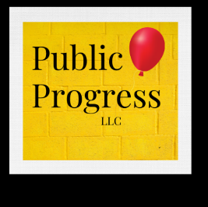 | thepublicprogress.com
 | www.solutiontree.com/st-states/iowa

