UEN Legislative Update
May 5, 2022
Week Seventeen of the 2022 Session: The Governor signed some bills. No legislative movement on the Budget or School Choice. This UEN Weekly Report from the 2022 Legislative Session covers the following:
- A Little Senate Action
- Governor Signs a Few Bills
- SF 2369 Governor’s School Choice/Voucher Omnibus
- Appropriations Bill Status
- Advocacy Actions and Links to Advocacy Resources

A Little Senate Action: The House took no action this week, just gaveling in and out to meet procedural requirements. The Senate approved several smaller bills this week, including HF 2127 Childcare Reimbursements: allows a childcare provider to collect the difference between the amount of state assistance and the amount the provider normally charges from a family in the childcare assistance program. The House approved the bill, 61:37 on March 2, the Senate approved it this week on a 29-16 vote, sending it to the Governor. UEN did not register on this bill.
Governor Signs Some Bills: the following bills of interest to school districts were among those signed by the Governor this week.
HF 2330 Electronic Insurance Policies: allows an employer to consent to the electronic delivery to group health plan documents to the employee members, unless there is a federal requirement specifying modes of delivery. Requires the employees to receive paper notice prior to the start of electronic delivery. Requires notice each time a document is posted on the internet as to what is in the document. Requires that employees who request paper copies receive a copy without charge. The House passed the bill 97-0 and the Senate passed it 48-0. The Governor signed it May 2. UEN did not register on this bill.
SF 2322 Copying Records Costs: requires copying costs for public records to be reasonable. Allows for appeals of the costs. Does not allow costs for legal counsel unless those legal costs are for the review or redaction of records that are confidential. The Senate passed the bill 48-0 and the House passed the bill 93-0. The Governor signed in May 2. UEN was registered as undecided.
Governor’s School Choice/Voucher Omnibus Bill: SF 2369 Governor’s School Choice/Voucher Omnibus bill is still in the House Appropriations Committee without a subcommittee assigned or any meeting schedule. The March 31 weekly report provided all of the details, including the Parents’ Rights Provisions and Policies to Address Teacher Shortages amended onto the bill. Pro-voucher groups have initiated contacts to encourage support. See advocacy actions below. One more outreach from public school leaders is warranted. UEN is opposed to this bill, although we support several of the teacher recruitment and retention policies that were amended onto the bill in the Senate.

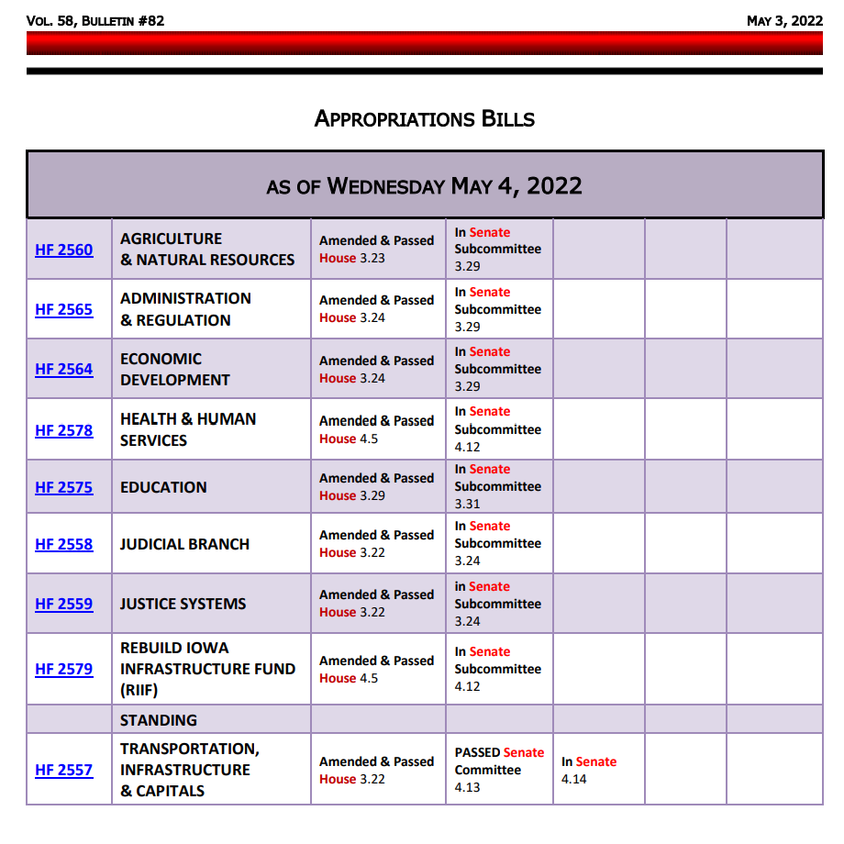
Status of Appropriations: the following table, from the IALNS Bulletin, May 3, 2002, shows the progress of appropriations bills, all of which have been approved by the House with no action in the Senate but for the Transportation, Infrastructure and Capitals bill. The only remaining budget bill not discussed in the House is the Standings Appropriations bill, which includes state foundation aid, typically introduced as the last budget bill of the Session.
See the March 31 UEN Weekly Report for details of the Education Appropriations Bill HF 2575. One specific detail worthy of mention: Division X of HF 2575, amended onto the bill in the House, would have prohibited school boards from giving an outgoing superintendent severance pay exceeding three months of salary. Sen. Cournoyer, chair of the Senate Education Appropriations Committee, has told us that she intends to remove that provision from the bill in the Senate.
Advocacy Actions This Week: One More Ask to Oppose SF 2369
Several pro-voucher advocacy organizations have been encouraging members to connect legislature to encourage support of SF 2369. One more reminder from pro-public education groups is warranted. Contact your Representative and encourage their opposition. Talking points in the March 31 UEN School Choice Call to Action are still relevant.
Additionally, leaders in favor of the bill have mentioned that vouchers in other states improved public school outcomes for students. If you hear a similar reply from your legislator, refer to the April 28 UEN Weekly Report for policy details about Florida and Mississippi Education Savings Accounts policies that give good evidence of the opposite. And remember; Iowa already has considerable school choice options. There is no reason to believe that one more increment of competition would have any additional impact on quality.
- Watch your email for announcements if policies pop up that need quick outreach to legislators: As the Session winds down, we’ll keep you in the know

- Send a note to your legislators: As most are home awaiting the announcement of leadership compromises, this is a good time to circle back and reinforce your local connections. Thank them for working on teacher shortage policies, improving the transparency requirements to what’s workable, and for being there to represent you and your district. If they had committed to you their opposition to vouchers, you could thank them for that as well.
Find Representatives here: https://www.legis.iowa.gov/legislators/house
Find Senators here: https://www.legis.iowa.gov/legislators/senate
- Check out your new legislative district and primary candidates for the Nov. 2022 election. Enter your address in this new map lookup tool on the legislative website to confirm your House and Senate district numbers: https://www.legis.iowa.gov/legislators/redistricting. Find names, phone numbers and home email addresses for primary candidates on the Iowa Secretary of State’s website, which publishes this information in a pdf found here: https://sos.iowa.gov/elections/pdf/Candidates/primarycandidatelist.pdf. Call them or send them a note, introduce yourself, offer to be a resource for them on education issues, and let them know what they can do to best represent and support the students, families and staff in your school district.
Connecting with Legislators at the Statehouse: To call and leave a message for a Senator, call the Senate switchboard operator number is 515.281.3371. To call and leave a message for a representative, the House switchboard operator number is 515.281-3221. You can ask if they are available or leave a message for them to call you back. You can also ask them what’s the best way to contact them during Session. They may tell you email, text message or phone call is the best way to connect with them during the Session, based on their personal preferences.
UEN Advocacy Resources: Check out the UEN Website at www.uen-ia.org to find Advocacy Resources such as Issue Briefs, UEN Weekly Legislative Reports and Weekly Capitol Video Updates, UEN Calls to Action when immediate advocacy action is required, testimony presented to the State Board of Education, the DE or any legislative committee or public hearing, and links to fiscal information that may inform your work. The latest legislative actions from the Statehouse will be posted at: www.uen-ia.org/blogs-list. See the 2022 UEN Advocacy Handbook, which is also available from the subscriber section of the UEN website.

Contact us with any questions, feedback or suggestions to better prepare your advocacy work:
Margaret Buckton
UEN Executive Director/Legislative Analyst
margaret@iowaschoolfinance.com
515.201.3755 Cell

